MATLAB with Python

Yann Debray

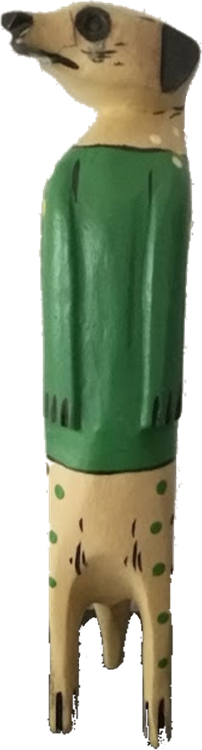

Table of Contents

1. Introduction 3

1.1. A brief history of scientific computing 3

1.2. About the author 5

1.3. Open-source vs Commercial 6

1.4. Who is this book for? 6

2. End-to-end project with MATLAB & Python 7

2.1. Call Python from MATLAB 8

2.2. Call MATLAB from Python 13

2.3. Generate a Python package from a set of MATLAB functions 13

3. Set-up MATLAB and Python 15

3.1. Install Python 15

3.2. Install Anaconda or other Python distribution 16

3.3. Manage your PATH 18

3.4. Install additional Python packages 19

3.5. Set up a Python virtual environment 20

3.6. Set up a Python Development Environment 20

3.7. Connect MATLAB to Python 24

3.8. Install the MATLAB Engine for Python 25

4. Call Python from MATLAB 26

4.1. Execute Python statements and files in MATLAB 26

4.2. Execute Python code in a MATLAB Live Task 26

4.3. Basic syntax of calling Python functions from MATLAB 28

4.4. Call Python User Defined Functions from MATLAB 30

4.5. Call Python community packages from MATLAB 37

4.6. Debug Python code called by MATLAB 41

4.7. Mapping data between Python and MATLAB 44

5. Call Python AI libraries from MATLAB 51

5.1. Call Scikit-learn from MATLAB 51

5.2. Call TensorFlow from MATLAB 57

5.3. Import TensorFlow model into MATLAB 61

# Introduction

Engineers and scientists that I meet every day think about MATLAB & Python as MATLAB **vs** Python. The goal of this book is to prove to them that it is possible to think about it as MATLAB **with** Python.

Python recently became the most used programming language[1]. It is general purpose by nature, and it is particularly used for scripting, web development and Artificial Intelligence (Machine Learning & Deep Learning).

MATLAB is mostly seen as a programming language for technical computing, and a development environment for engineers and scientists. But MATLAB also provides flexible two-way integration with many programming languages including Python.

MATLAB works with common python distributions. For this book I will be using Python 3.10 (downloaded on [Python.org](https://www.python.org/downloads/)) and MATLAB 2023a.

## A brief history of scientific computing

### The roots of numerical analysis

In the 1970s, Cleve Moler took actively part in the development of Fortran libraries called EISPACK[2] (to compute eigenvalues) and LINPACK[3] (for linear algebra). As he was professor of Mathematics at the University of New Mexico, he wanted to make those libraries accessible to student while sparing them the need to write Fortran wrapper code, compile it, debug it, compile again, run, …

So he created an interactive interpreter in Fortran for matrix computation, called MATLAB (short for MATrix LABoratory, nothing to do with the Matrix movie, that came out 30 years later). This first version was based on a few routines from EISPACK and LINPACK and only contained 80 functions.

This photo of a MATLAB manual at the time, shows the scope of the software in its early days.

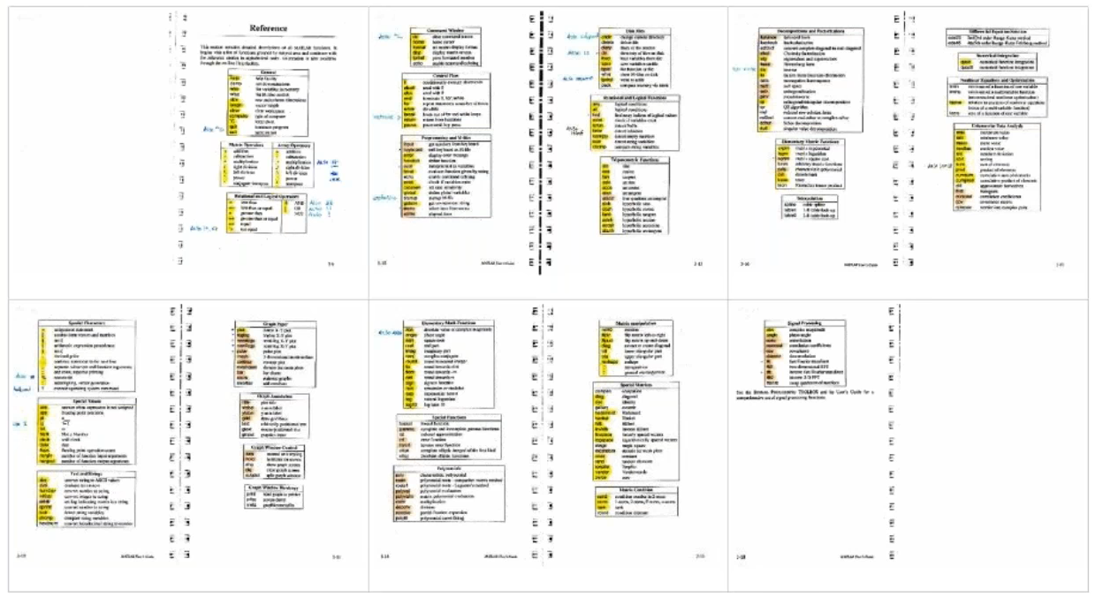

At that time MATLAB was not yet a programming language. It had no file extension (m-scripts), no toolboxes. The only available datatype was matrices. The graphic capabilities were asterisks drawn on the screen (not Astérix The Gaul).

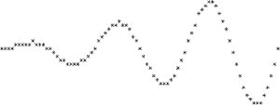

In order to add a function, you had to modify the Fortran source code and recompile everything. So the source code was open, because it needed to be (open-source only appeared in the 80s, with Richard Stallman and the Free Software movement).

After a course on numerical analysis that Cleve Moler gave at Stanford University in California, an MIT trained engineer came to him: “I introduced myself to Cleve”. This is the way Jack Little tells the story about their first encounter. Jack Little had anticipated the possible use of MATLAB on PC, and rewritten it in C. He knew, like Steve Jobs and Bill Gates that Personal Computing would win over the mainframe server business of IBM. He also added the ability to write program files to extend the capabilities of the software, and toolboxes that would become a well architectured, modular and scalable business model. In 1984, he created the company (The) MathWorks to commercialize MATLAB.

**Read more about the origins of MATLAB:**

* A history of MATLAB – published in June 20202 - <https://dl.acm.org/doi/10.1145/3386331>
* The Origins of MATLAB <https://www.mathworks.com/company/newsletters/articles/the-origins-of-matlab.html>
* Cleve’s Corner – History of MATLAB Published by the ACM [https://blogs.mathworks.com/cleve/2020/06/13/history-of-matlab-published-by-the-acm/](https://blogs.mathworks.com/cleve/2020/06/13/history-of-matlab-published-by-the-acm/?doing_wp_cron=1642533843.1107759475708007812500)

### In a parallel universe

In the 1980s, Guido van Rossum was working at the [Centrum Wiskunde & Informatica](https://en.wikipedia.org/wiki/Centrum_Wiskunde_%26_Informatica) (abbr. **CWI**; English: "National Research Institute for Mathematics and Computer Science") on a language called ABC.

“ABC was intended to be a programming language that could be taught to intelligent computer users who were not computer programmers or software developers in any sense. During the late 1970s, ABC's main designers taught traditional programming languages to such an audience. Their students included various scientists—from physicists to social scientists to linguists—who needed help using their very large computers. Although intelligent people in their own right, these students were surprised at certain limitations, restrictions, and arbitrary rules that programming languages had traditionally set out. Based on this user feedback, ABC's designers tried to develop a different language.”

In 1986 Guido van Rossum moved to a different project at CWI, the Amoeba project. Amoeba was a distributed operating system. By the late 1980s, they realized that they needed a scripting language. With the freedom he was given inside this project, Guido van Rossum started his own “mini project”.

In December 1989, Van Rossum had been looking for a "'hobby' programming project that would keep [him] occupied during the week around Christmas" as his office was closed when he decided to write an interpreter for a "new scripting language [he] had been thinking about lately: a descendant of ABC that would appeal to Unix/C hackers". He attributes choosing the name "Python" to "being in a slightly irreverent mood (and a big fan of Monty Python's Flying Circus)".[4]

He wrote a simple virtual machine, a simple parser and a simple runtime. He created a basic syntax, using indentation for statement grouping. And he developed a small number of datatypes: dictionaries, lists, strings and numbers. Python was born. In Guido’s opinion, his most innovative contribution to Python’s success was making it easy to extend.

**Main milestones of the Python language:**

* 1991: Python 0.9.0 published to alt.sources by Guido Van Rossum
* 1994: Python 1.0. include functional programming (lambda’s map, filter, reduce)
* 2000: Python 2.0 introduces list comprehension and garbage collection
* 2008: Python 3 fixes fundamental design flaws and is not backward compatible
* 2022: Python 2 is end of life, last version 2.7.18 released

**Read more about Python:**

* The Making of Python - A Conversation with Guido van Rossum, Part I <https://www.artima.com/articles/the-making-of-python>
* Microsoft Q&A with Guido van Rossum, Inventor of Python  
  <https://www.youtube.com/watch?v=aYbNh3NS7jA>
* The Story of Python, by Its Creator, Guido van Rossum  
  <https://www.youtube.com/watch?v=J0Aq44Pze-w>
* Python history timeline infographics  
  <https://python.land/python-tutorial/python-history>

## About the author

My name is Yann Debray, and I work for MathWorks, as a MATLAB Product Manager. You will probably think that I am biased, in that I am trying to sell you MATLAB. That’s not wrong. But to better understand my motivations, you need to look a little deeper into my background.

I joined MathWorks in June 2020 (in the middle of the COVID-19 pandemic). Prior to that, I spent 6 years working on a project called Scilab[5]. Scilab is an open-source alternative to MATLAB. This experience translates my appetite for open-source and scientific computing.

My first professional encounter with numerical computing after college was in December 2013, when I met Claude Gomez[6]. He was the CEO of Scilab Enterprises back then, and the one who had turned Scilab from a research project to a company. The business model was inspired from Red Hat selling services around Linux.

I know very well the challenge of making open-source a sustainable model in scientific computing, and that is the reason why I believe in an equilibrium in the force, between open-source and proprietary software. Not every software can be free. Based on the expertise required in fields like simulation – requiring decades of investments – we will still observe entire markets of engineering software driven by intellectual property for the years to come.

## Open-source vs Commercial

One of the early questions around this book was: *Do I commercialize it, or do I make it open-source?*

I had an idealized view of what it would mean to write a book. The fame and the glamour. But pragmatically, I know it is not going to sell a lot, as it is quite niche. My best estimate for a target audience is around 30% of the 5 million users of MATLAB, that may also be interested in Python.

Beyond my idealism on open-source, I felt like I needed concrete motivation to see this project through. Hence my initial idea to sell a hard copy of this book. But my dear colleague and good friend Mike Croucher advised me against what he calls “dead wood”. Hinting to the fact that the printed content would quickly become obsolete with every new version of MATLAB (twice a year).

Finally, I’ve decided that open-sourcing the content does not conflict with releasing a paid version of the book. In fact, when I buy technical books, I often decide for those who apply an open-source license.

## Who is this book for?

If you recognize yourself in the following scenario, this book is for you:

You are an engineer or a researcher using MATLAB, and you are increasingly hearing about Python. This comes up particularly in subjects related to data science & artificial intelligence. When searching for code online, you might stumble on interesting scripts or packages written in Python. Or when working with colleagues that are using Python, you may be looking for ways to integrate their work:



You are (or want to become) a Data Scientist, and you are working on scientific / engineering data (wireless, audio, video, radar/lidar, autonomous driving,…). You will probably be using Python for some of your daily operations related to data processing, but you may want to consider MATLAB for the engineering part of your AI workflow (especially if this intelligence will be integrated on embedded systems). If this part is covered by engineer colleagues, you might simply want to be able to run the models and scripts that they share with you:

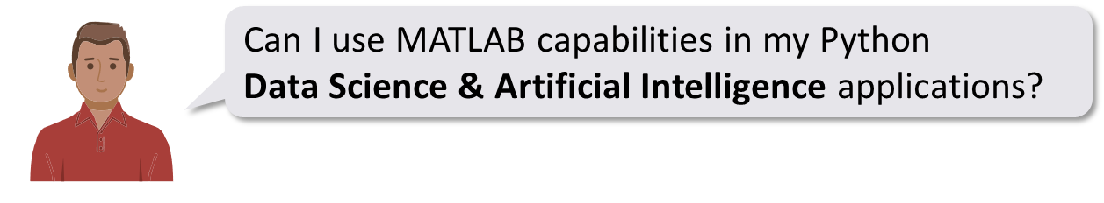

# End-to-end project with MATLAB & Python

When I joined MathWorks, I met Heather. She had developed a really good demo to illustrate the use of MATLAB with Python. In this chapter, I’ll show the **Weather Forecasting app** she developed. You can find the code on her GitHub repo: <https://github.com/hgorr/weather-matlab-python>

Start by retrieving the code by downloading a zip or cloning the repository:

!git clone https://github.com/hgorr/weather-matlab-python

cd weather-matlab-python\

The resulting application will look like this:

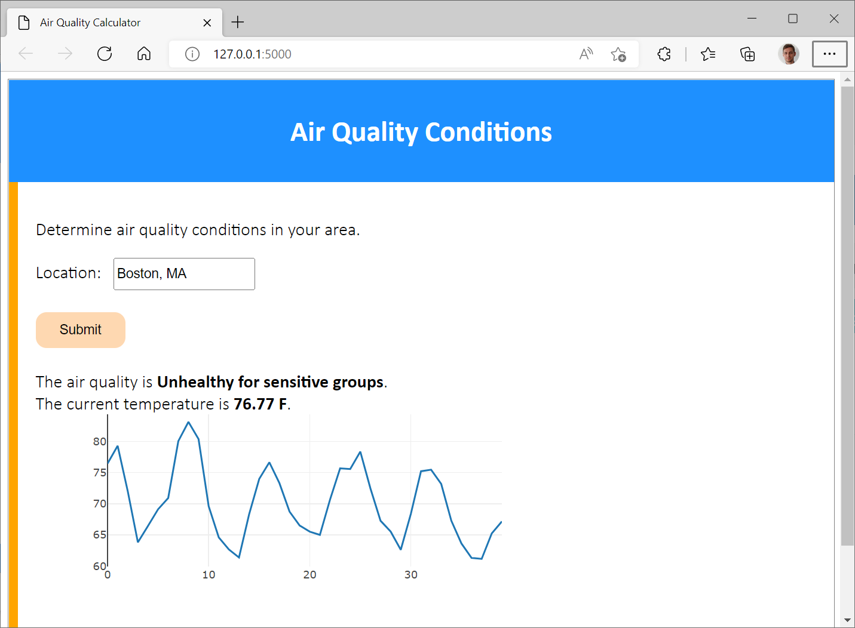

We will work in steps to:

1. Call Heather's python code to retrieve the weather data
2. Integrate a MATLAB model predicting the air quality
3. Deploy the resulting application made out of MATLAB + Python

In this example we will be using data from a web service at [openweathermap.org](https://openweathermap.org/)

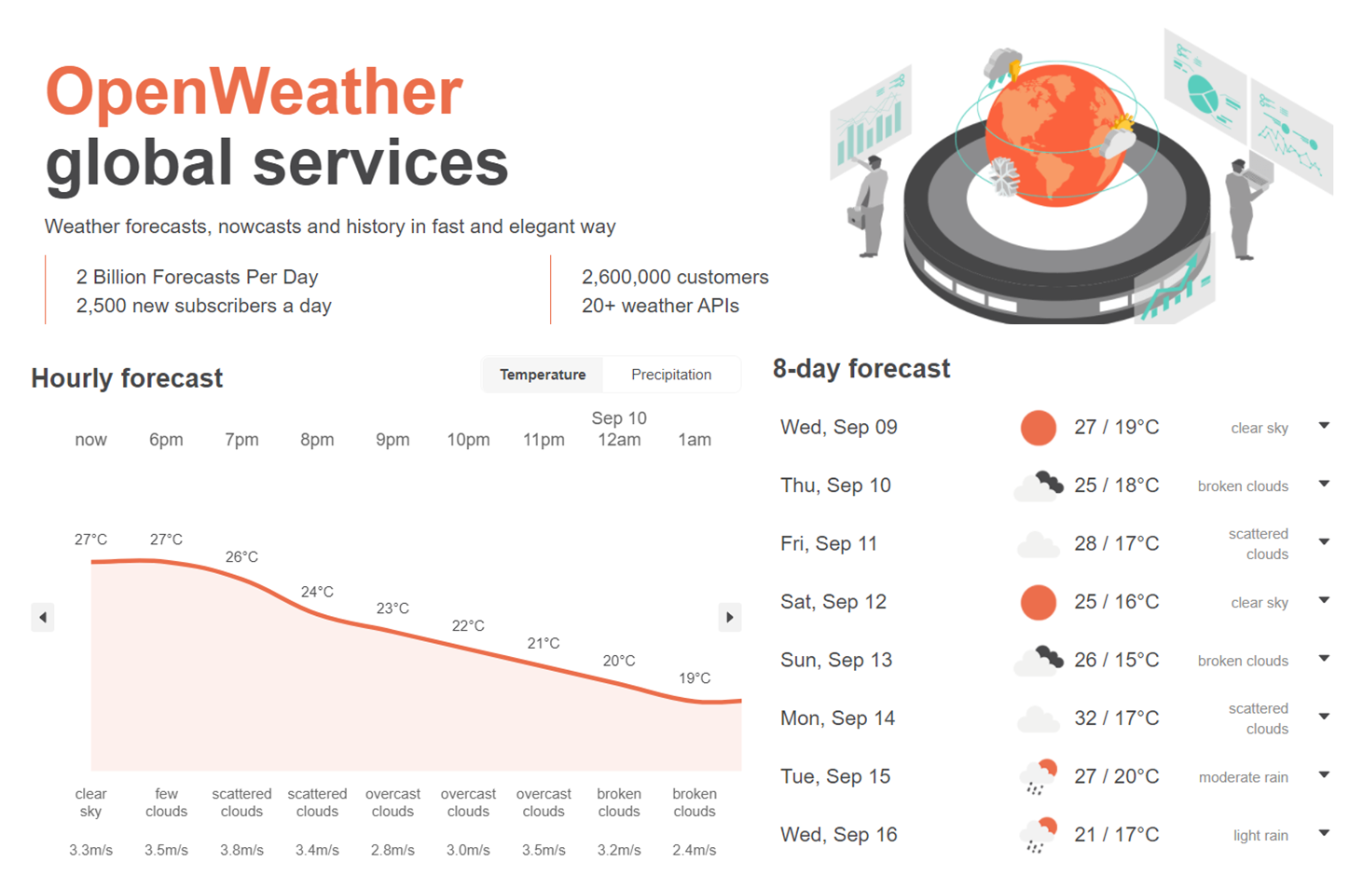

In order to access live data, you will need to register[7] to the free tier offering. You will then have the option to generate an API key: <https://home.openweathermap.org/api_keys>

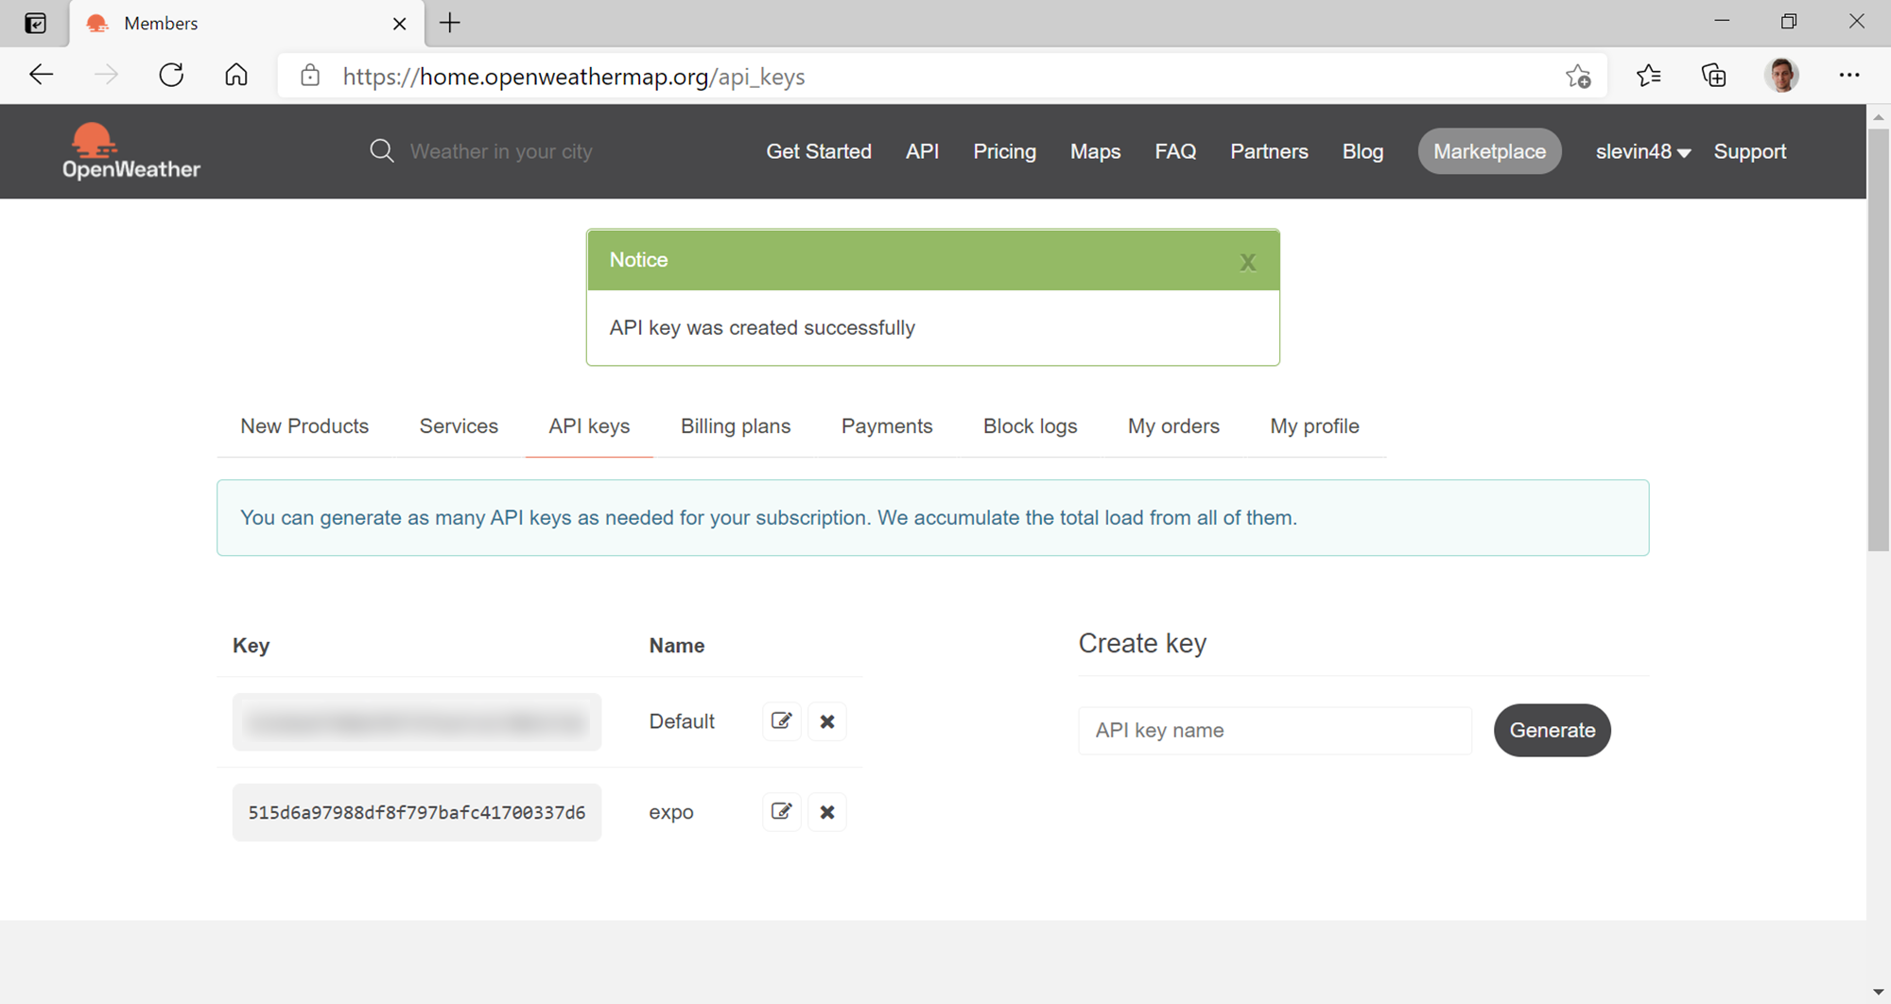

This key will be necessary for each call of the web service. For instance, requesting the current weather[8] will be performed by calling the following address:

api.openweathermap.org/data/2.5/weather?q={city name}&appid=[{API key}](https://home.openweathermap.org/api_keys)

Save your API key in a text file called accessKey.txt.

% apikey = fileread("accessKey.txt");

Alternatively you can use the sample API key (as demonstrated in this script)

appid ='b1b15e88fa797225412429c1c50c122a1';

## Call Python from MATLAB

Heather has created a module called [weather.py](https://github.com/hgorr/weather-matlab-python/blob/main/weather.py) that reads from the web service and parses the JSON data it returns. Of course, we can do this in MATLAB, but let’s use this module as an example of accessing data from Python.

### Check the Python installation

First connect to the Python environment using the pyenv[9] command. For more details on how to set-up MATLAB and Python, look at the next chapter. MATLAB can call python functions and create python objects from base Python, from packages you have installed and from your own Python code.

pyenv % Use pyversion for MATLAB versions before R2019b

ans =

PythonEnvironment with properties:

Version: "3.10"

Executable: "C:\Users\...\python-3.10.4.amd64\python.exe"

Library: "C:\Users\...\python-3.10.4.amd64\python310.dll"

Home: "C:\Users\...\python-3.10.4.amd64"

Status: NotLoaded

ExecutionMode: OutOfProcess

### Call Python user-defined functions from MATLAB

Now let's see how to use my colleague’s weather module. We will start by getting the data for today. The [get_current_weather](https://github.com/hgorr/weather-matlab-python/blob/c8985b96b4c4a64b283573a5276d25f33f311bcc/weather.py#L16) function in the weather module gets the current weather conditions in Json format. The [parse_current_json](https://github.com/hgorr/weather-matlab-python/blob/c8985b96b4c4a64b283573a5276d25f33f311bcc/weather.py#L42) function then returns that data as a python dictionary.

jsonData = py.weather.get_current_weather("London","UK",appid,api='samples')

jsonData =

Python dict with no properties.

{'coord': {'lon': -0.13, 'lat': 51.51}, 'weather': [{'id': 300, 'main': 'Drizzle', 'description': 'light intensity drizzle', 'icon': '09d'}], 'base': 'stations', 'main': {'temp': 280.32, 'pressure': 1012, 'humidity': 81, 'temp_min': 279.15, 'temp_max': 281.15}, 'visibility': 10000, 'wind': {'speed': 4.1, 'deg': 80}, 'clouds': {'all': 90}, 'dt': 1485789600, 'sys': {'type': 1, 'id': 5091, 'message': 0.0103, 'country': 'GB', 'sunrise': 1485762037, 'sunset': 1485794875}, 'id': 2643743, 'name': 'London', 'cod': 200}

weatherData = py.weather.parse_current_json(jsonData)

weatherData =

Python dict with no properties.

{'temp': 280.32, 'pressure': 1012, 'humidity': 81, 'temp_min': 279.15, 'temp_max': 281.15, 'speed': 4.1, 'deg': 80, 'lon': -0.13, 'lat': 51.51, 'city': 'London', 'current_time': '2023-03-15 16:04:38.427888'}

### Convert Python data to MATLAB data

Let’s convert the Python dictionary[10] into a MATLAB structure[11]:

data = struct(weatherData)

data = struct with fields:

temp: 280.3200

pressure: [1×1 py.int]

humidity: [1×1 py.int]

temp_min: 279.1500

temp_max: 281.1500

speed: 4.1000

deg: [1×1 py.int]

lon: -0.1300

lat: 51.5100

city: [1×6 py.str]

current_time: [1×26 py.str]

Most of the data gets automatically converted. Only some fields did not find an obvious equivalent:

* pressure & humidity remain as a py.int object in MATLAB.
* city and current_time remain as a py.str object in MATLAB.

We can convert them explicitly using standard MATLAB functions like double[12], string [13]and datetime[14]:

data.pressure = double(data.pressure);

data.humidity = double(data.humidity);

data.deg = double(data.deg);

data.city = string(data.city);

data.current_time = datetime(string(data.current_time))

data = struct with fields:

temp: 280.3200

pressure: 1012

humidity: 81

temp_min: 279.1500

temp_max: 281.1500

speed: 4.1000

deg: 80

lon: -0.1300

lat: 51.5100

city: "London"

current_time: 15-Mar-2023 16:04:38

### Convert Python lists to MATLAB matrices

Now let's call the [get_forecast](https://github.com/hgorr/weather-matlab-python/blob/c8985b96b4c4a64b283573a5276d25f33f311bcc/weather.py#L67) function which returns a series of predicted weather conditions over the next few days. We can see that the fields of the structure are returned as Python list[15]:

jsonData = py.weather.get_forecast('Muenchen','DE',appid,api='samples');

forecastData = py.weather.parse_forecast_json(jsonData);

forecast = struct(forecastData)

forecast = struct with fields:

current_time: [1×36 py.list]

temp: [1×36 py.list]

deg: [1×36 py.list]

speed: [1×36 py.list]

humidity: [1×36 py.list]

pressure: [1×36 py.list]

Lists containing only numeric data can be converted into doubles (since MATLAB R2022a):

forecast.temp = double(forecast.temp) - 273.15; % from Kelvin to Celsius

forecast.temp

ans = *1×36*

13.5200 12.5100 3.9000 -0.3700 0.1910 2.4180 3.3280 ⋯

Lists containing text can be transformed to strings, and further processed into specific data types like datetime:

forecast.current_time = string(forecast.current_time);

forecast.current_time = datetime(forecast.current_time);

forecast.current_time

ans = *1×36 datetime*

16-Feb-2017 12:00:0016-Feb-2017 15:00:0016-Feb-2017 18:00:0016-Feb-2017 21:00: ⋯

Read more about mapping data between Python and MATLAB (section 4.7)

### Explore graphically the Python data imported in MATLAB

plot(forecast.current_time,forecast.temp)

xtickangle(45)

xlabel('Date')

ylabel('Temperature')

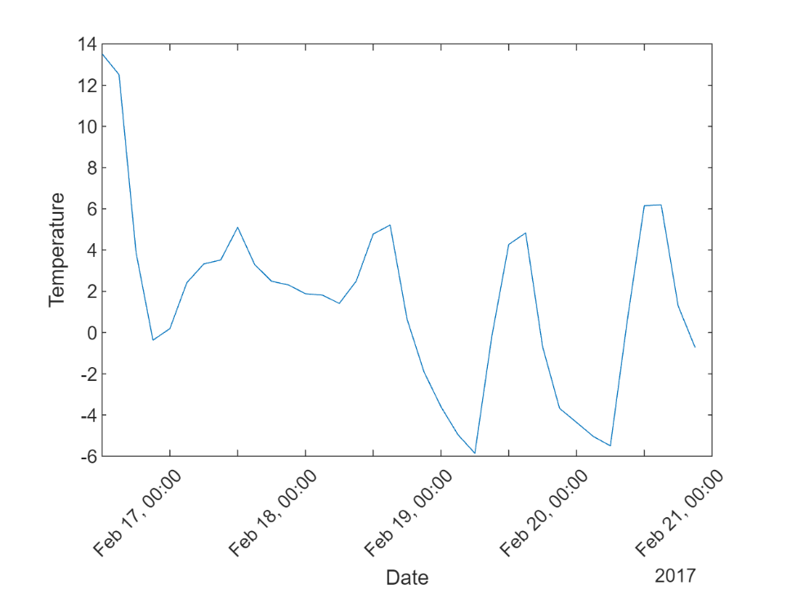

### Call a Machine Learning model in MATLAB

Now let's suppose we have used some historical data to create a machine learning model that takes a set of weather conditions and returns a prediction of the air quality. My Python colleague wants to make use of my model in her Python code.

First, let's see how the air quality prediction works. There are three steps:

* Load the model from a .mat file
* Convert the current weather data from openweathermap.org to the format expected by the model
* Call the predict method of the model to get the expected air quality for that day

load airQualModel.mat model

testData = prepData(data);

airQuality = predict(model,testData)

airQuality = categorical

Good

To give this to my colleague, I'm going to pack up these steps into a single function called [predictAirQuality](https://github.com/hgorr/weather-matlab-python/blob/main/predictAirQual.m):

function airQual = predictAirQual(data)

% PREDICTAIRQUAL Predict air quality, based on machine learning model

%

%#function CompactClassificationEnsemble

% Convert data types

currentData = prepData(data);

% Load model

mdl = load("airQualModel.mat");

model = mdl.model;

% Determine air quality

airQual = predict(model,currentData);

% Convert data type for use in Python

airQual = char(airQual);

end

This function does the same three steps as above – loads the model, converts the data, and calls the model's predict method.

However, it has to do one other thing. The model returns a MATLAB categorical value which doesn't have a direct equivalent in Python, so we convert it to a character array.

Now that we have our MATLAB function that uses the air quality prediction model, let's see how to use it in Python.

## Call MATLAB from Python

Here we will demonstrate calling MATLAB from Python inside of a simple Python shell (>>>).

The first step is to use the engine API to start a MATLAB running in the background for Python to communicate with (we will assume here that you have installed it already – else check section 3.8).

>>> import matlab.engine

>>> m = matlab.engine.start_matlab()

Once the MATLAB is running, we can call any MATLAB function on the path.

>>> m.sqrt(42.0)

6.48074069840786

We need to access the key from the txt file:

>>> with open("accessKey.txt") as f:

... apikey = f.read()

Now we can use the get_current_weather and the parse_current_json functions from the weather module just like we did in MATLAB to get the current weather conditions.

>>> import weather

>>> json_data = weather.get_current_weather("Boston","US",apikey)

>>> data = weather.parse_current_json(json_data)

>>> data

{'temp': 62.64, 'feels_like': 61.9, 'temp_min': 58.57, 'temp_max': 65.08, 'pressure': 1018, 'humidity': 70, 'speed': 15.01, 'deg': 335, 'gust': 32.01, 'lon': -71.0598, 'lat': 42.3584, 'city': 'Boston', 'current_time': '2022-05-23 11:28:54.833306'}

Then we can call the MATLAB function predictAirQuality to get the predicted result.

>>> aq = m.predictAirQuality(data)

>>> aq

Good

The last step is to shutdown the MATLAB started by the engine API at the beginning of our notebook.

>>> m.exit()

However, your Python colleague might not have access to MATLAB. The next two sections will target this use case.

## Generate a Python package from a set of MATLAB functions

For this, you will need to use a dedicated toolbox called MATLAB Compiler SDK[16]. You can select the Library Compiler in the Apps ribbon, or enter in the Command Window (libraryCompiler):

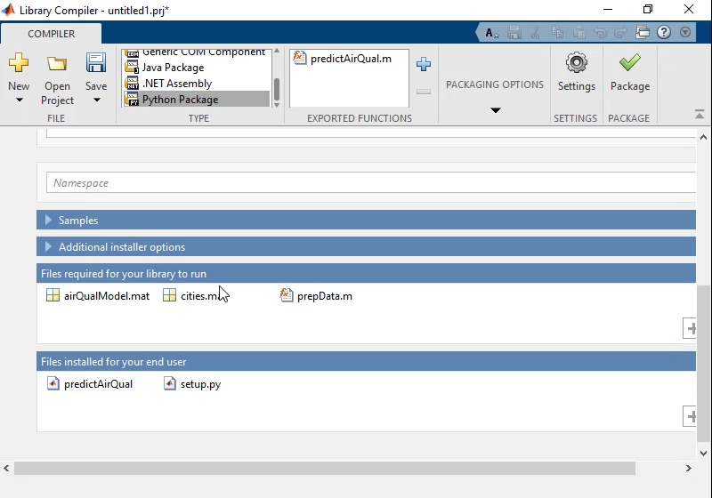

Simply select the MATLAB function(s) that you want to turn them into Python functions. The dependencies will be automatically added to the Python package (in this case, the Air Quality Model, the list of cities, and the pre-processing function).

This packages the files we need and creates a*setup.py* and *readme.txt* file with instructions for the Python steps. To learn more on how to set-up the generated package read the section 7.1.

Then we need to import and initialize the package and can call the functions, like so:

>>> import AirQual

>>> aq = AirQual.initialize()

>>> result = aq.predictAirQual()

When we’re finished, wrap things up by terminating the process:

>>> aq.terminate()

We can go one step further in sharing the MATLAB functionality to be used as a web service (and potentially accessed by many users at once). In this case, MATLAB Production Server[17] can be used for load balancing and the MATLAB code can be accessed through a RESTful API[18] or Python client[19].

# Set-up MATLAB and Python

## Install Python

You can simply go to [www.python.org/downloads](https://www.python.org/downloads/) and select a version of Python compatible with your MATLAB version[20]. For instance, this is the list of versions compatible with the latest releases:

|  |  |  |
| --- | --- | --- |
| MATLAB Version | Compatible Versions of Python 2 | Compatible Versions of Python 3 |
| R2023a | 2.7 | 3.9, 3.10 |
| R2022b | 2.7 | 3.8, 3.9, 3.10 |
| R2022a | 2.7 | 3.8, 3.9 |
| R2021b | 2.7 | 3.7, 3.8, 3.9 |

### Install Python on Windows

If you are running on Windows, download the Windows installer (64-bit)[21]: the file python-3.10.10-amd64.exe is only 28Mo. Just run this executable (you can uncheck the admin privileges):

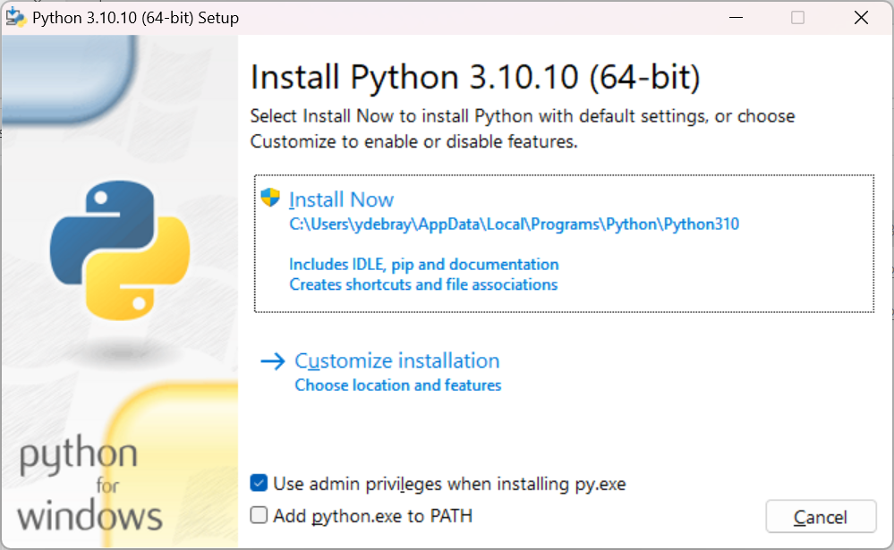

By default, the checkbox “Add python.exe to PATH” isn’t checked. I would advise you to select it (Otherwise, you will have to add Python to your PATH manually):

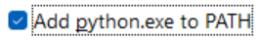

Select “à Install Now”:

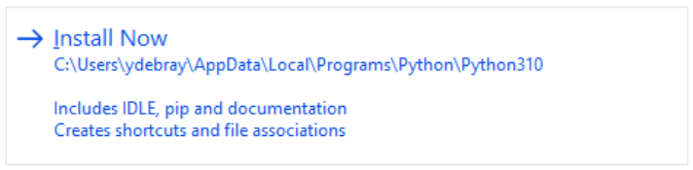

It should only take about a minute to get everything installed on your machine.

The following applications have been installed and are accessible from your Start menu:

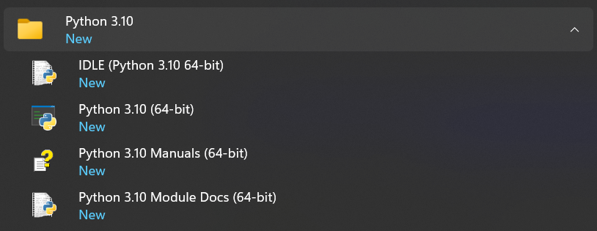

To check that you have Python installed and available to your PATH, open a command prompt:

C:\Users\ydebray>where python  
C:\Users\ydebray\AppData\Local\Programs\Python\Python310\python.exe  
C:\Users\ydebray\AppData\Local\Microsoft\WindowsApps\python.exe

If you have several versions of Python installed, it will return each of them, in the order listed in your PATH, plus the last one that isn’t actually installed: C:\Users\ydebray\AppData\Local\Microsoft\WindowsApps\python.exe

This is a link to a version packaged on the Microsoft Store. If you run it, you’ll be redirect to the Store:

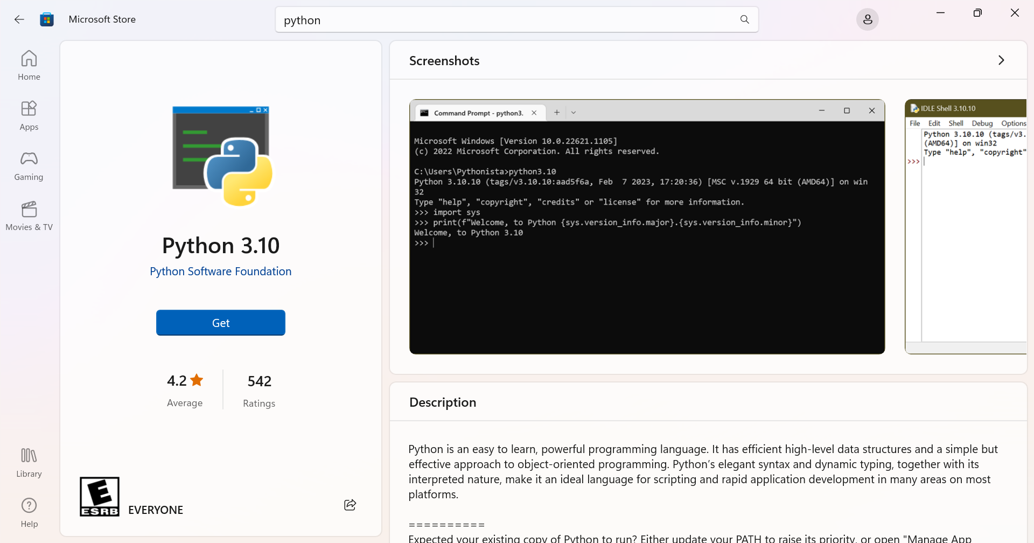

## Install Anaconda or other Python distribution

With the previous version installed, you only have the base Python language. No numerical packages, or Development Environment (unlike MATLAB that ships all of those features by default). To get a set of curated data science packages pre-installed, you can download a distribution, like Anaconda:

Be aware of the fact that you now need to comply with Anaconda’s terms of services[22] (since September 2020): You can only use the open-source Anaconda Distribution[23] professionally for free if you are not part of an organization with more than 200 employees. Otherwise, you will need to buy a license of Anaconda Professional[24].

If you are searching for an alternative distribution to Anaconda, I would recommend WinPython[25] on Windows. If you are running on Linux, I believe you don’t need a distribution and can manage packages yourself.

### Install Miniconda from conda-forge

Conda-forge[26] provides installers of the conda[27] package manager that point by default to the community channel, to remain in compliance with the terms of use of the Anaconda repo, even for “commercial activities”.

Download and run the installer of miniforge (55 MB):

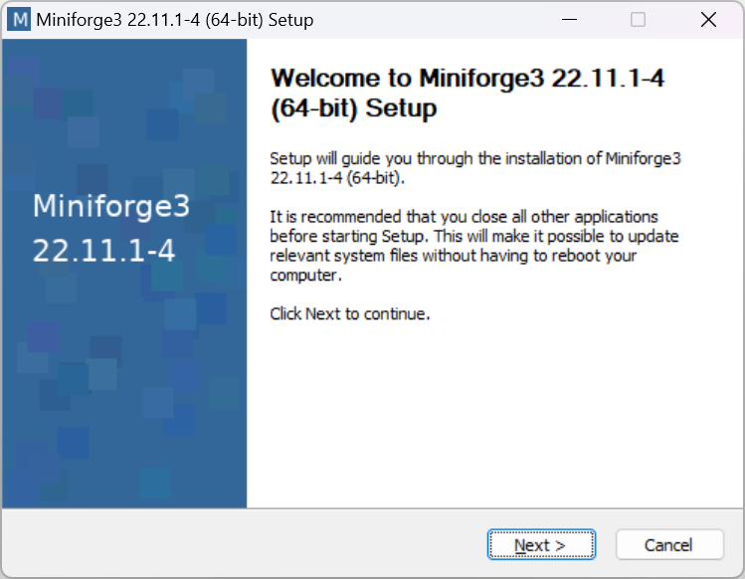

### Install Micromamba for minimal footprint

micromamba[28] is a 4 MB pure-C++ drop-in replacement for the conda package manager. Unlike pip or conda, it is not written in Python, so you don’t need to get Python to get it, and it can retrieve python:

(base) $ mamba install python

__ __ __ __

/ \ / \ / \ / \

/ \/ \/ \/ \

███████████████/ /██/ /██/ /██/ /████████████████████████

/ / \ / \ / \ / \ \____

/ / \_/ \_/ \_/ \ o \__,

/ _/ \_____/ `

|/

███╗ ███╗ █████╗ ███╗ ███╗██████╗ █████╗

████╗ ████║██╔══██╗████╗ ████║██╔══██╗██╔══██╗

██╔████╔██║███████║██╔████╔██║██████╔╝███████║

██║╚██╔╝██║██╔══██║██║╚██╔╝██║██╔══██╗██╔══██║

██║ ╚═╝ ██║██║ ██║██║ ╚═╝ ██║██████╔╝██║ ██║

╚═╝ ╚═╝╚═╝ ╚═╝╚═╝ ╚═╝╚═════╝ ╚═╝ ╚═╝

mamba (1.1.0) supported by @QuantStack

GitHub: https://github.com/mamba-org/mamba

Twitter: https://twitter.com/QuantStack

█████████████████████████████████████████████████████████████

Looking for: ['python']

conda-forge/noarch 11.6MB @ 3.6MB/s 3.7s

conda-forge/linux-64 30.3MB @ 3.7MB/s 9.4s

## Manage your PATH

When you have several versions of Python installed, the command python returns the version that is higher up in your PATH. To check which version of Python is used by default:

C:\Users\ydebray>python --version  
Python 3.10.10

To change this, you will need to modify your PATH[29]

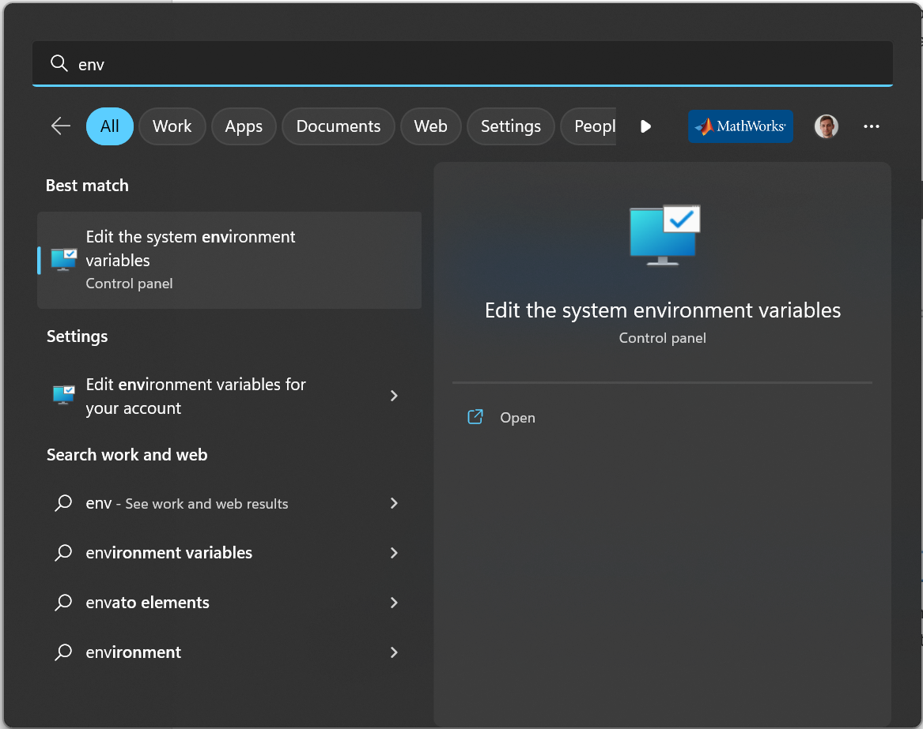

You can edit your PATH in **environment variables**, by tipping “path” in the search bar of your Windows start menu. Select the Path in the user variables (it will be written on top of the system variables):

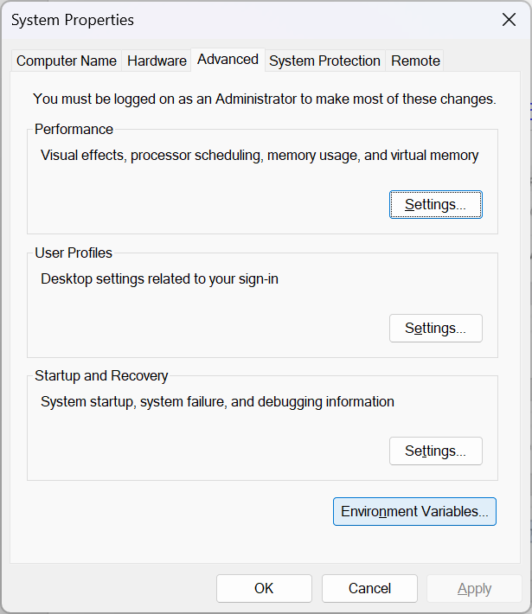 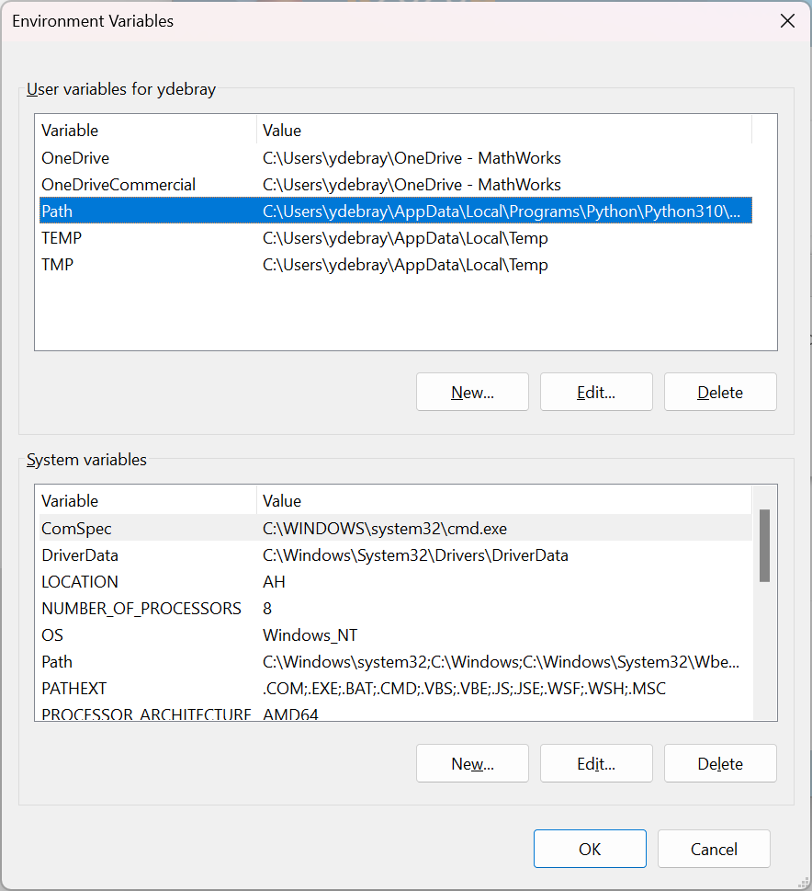

You can modify the order in which each version of Python is listed in the PATH. And in order to access pip (the Python default package manager), make sure to also list the Script folder in the PATH:

C:\Users\ydebray\AppData\Local\Programs\Python\Python310\Scripts

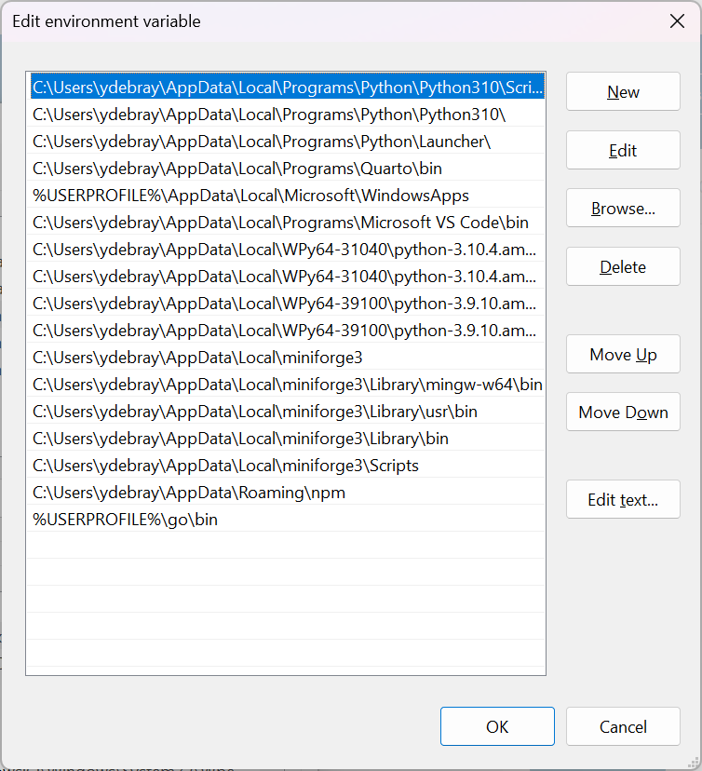

## Install additional Python packages

In order to retrieve additional packages from the Python Package Index[30], use the pip command:

C:\Users\ydebray>pip install pandas

This will for instance install the famous pandas[31] package. It will also automatically retrieve its dependencies (in this case numpy, python-dateutil, pytz).

You can check if a package is installed by calling the method pip show. It will show information about this package:

C:\Users\ydebray>pip show pandas

Name: pandas

Version: 1.3.3

Summary: Powerful data structures for data analysis, time series, and statistics

Home-page: https://pandas.pydata.org

Author: The Pandas Development Team

Author-email: pandas-dev@python.org

License: BSD-3-Clause

Location: c:\users\ydebray\appdata\local\programs\python\python39\lib\site-packages

Requires: numpy, python-dateutil, pytz

Required-by: streamlit, altair

To upgrade a package previously installed with a new version:

C:\Users\ydebray>pip install --upgrade pandas

## Set up a Python virtual environment

If you have different projects leveraging different versions of the same package, or if you want a way to replicate your production environment in a clean space, use Python virtual environment[32]. It’s a type of virtualization at the language level (like Virtual Machine at the Machine level, or Docker container at the Operating System level). This is the default way (shipped with base Python) to create a virtual environment called env:

C:\Users\ydebray>python -m venv env

You then need to activate it

- On Windows:

C:\Users\ydebray>.\env\Scripts\activate

- On Linux:

$ source env/bin/activate

Once you’ve done that you can install the libraries you want, for instance from a list of requirements:

C:\Users\ydebray>pip install -r requirements.txt

## Set up a Python Development Environment

Once you've installed Python and the relevant packages for scientific computing, you still don't quite have the same experience as with the MATLAB Integrated Development Environment (IDE).

Two key open-source technologies are taking a stab at reshaping the tech computing landscape:

* Jupyter Notebooks
* Visual Studio Code

They are redefining the way *Languages* and *Development environments* are interacting. Based on open standards for interactive computing first with Jupyter. Adding richer interaction for multiple languages in the IDE, with the VS Code Language Server Protocol.

### Jupyter Notebooks

Jupyter Notebooks have become over the years, one of the most used and appreciated data science tools. They combine text (as Markdown), code, and output (numerical and graphical). Notebooks help data scientist to communicate goals, methods and results. It can be seen as an executable form of textbook or scientific paper.

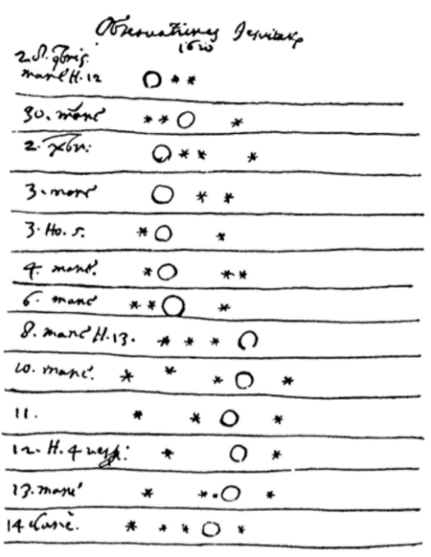Jupyter stands for Julia, Python and R, but it is also an homage to Galileo’s notebooks recording the discovery of the moons of Jupiter. Those notebooks were probably one of the first instance of open science, data-and-narrative papers. When Galileo published the Sidereal Messenger in 1610 (one of the first scientific paper), he actually published his observations with code and data. It was a log of the dates and the states of the night. There was data and metadata, and there was a narrative.

Jupyter is a project that spun off in 2014[33] from IPython. IPython stands for Interactive Python and was created in 2001 by Fernando Perez. He drew his inspiration from Maple and Mathematica that both had notebook environments. He really liked the Python language, but he felt limited by the interactive prompt to do scientific computing. So he wrote a python startup file to provide the ability to hold state and capture previous results for reuse, and adding some nice features like loading the Numeric library and Gnuplot. 'ipython-0.0.1'[34] was born, a mere 259 lines to be loaded as $PYTHONSTARTUP.

Around 2006, the IPython project took some inspiration from another open-source project called Sage[35]. The Sage Notebook was taking the route of using the filesystem for notebook operations. You couldn’t meaningfully list files with 'ls' or move around the filesystem by changing directory with 'cd'. Sage would execute your code in hidden directories with each cell actually being a separate subdirectory.

In 2010, the architecture of IPython evolved by separating the notebook front-end from the kernel executing Python code, and communicating between the two with the ZeroMQ protocol[36]. This design enabled the development of a Qt client, a Visual Studio extension, and finally a web frontend.

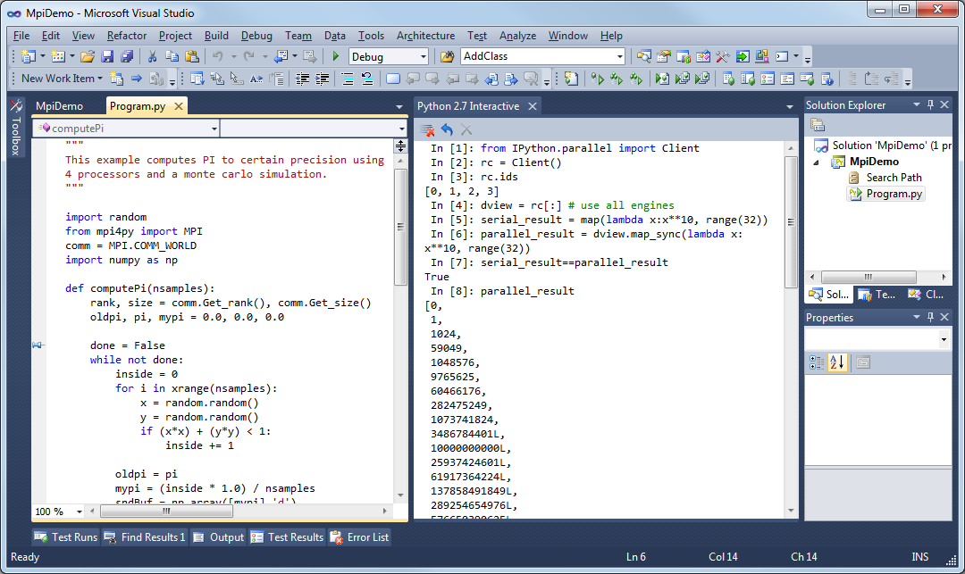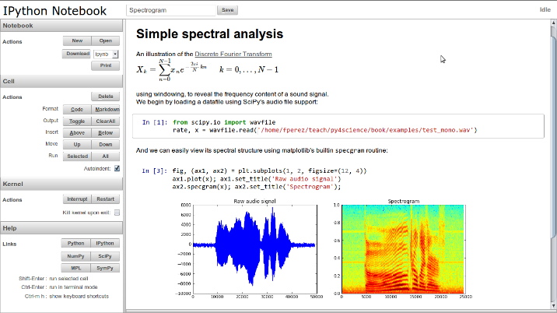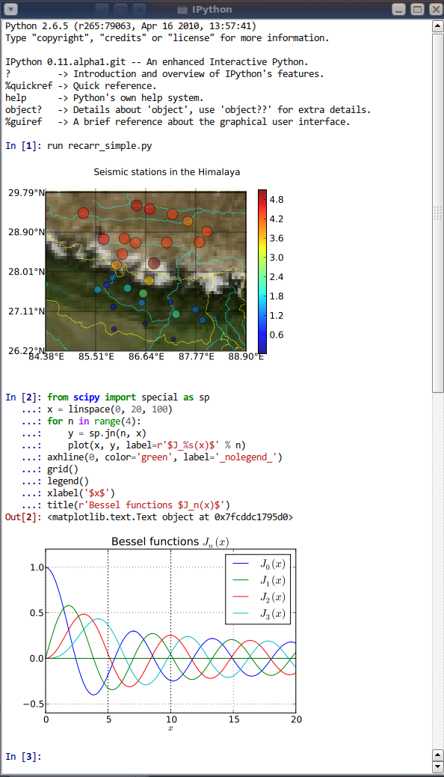

IPython gave turn to Jupyter, to become language agnostic. Jupyter supports execution environments (aka kernels) in several dozen languages among which are Julia, R, Haskell, Ruby, and of course Python (via the IPython kernel)… and MATLAB[37] (via a kernel maintained by the community and building on the MATLAB Engine for Python).

To summarize, Jupyter provides 3 key *components* to the modern scientific computing stack:

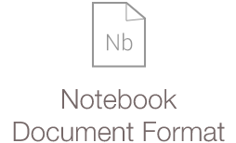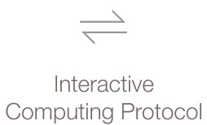 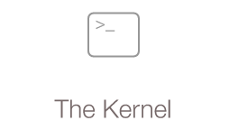

Some of the testimonies of the pervasive success of Jupyter in data science are the development of additional capabilities from the ecosystem:

* Running Notebooks on Google Colab
* Render Notebooks on GitHub

**Read more on Jupyter:**

* The scientific paper is obsolete, by James Somers – The Atlantic – APRIL 5, 2018  
  <https://www.theatlantic.com/science/archive/2018/04/the-scientific-paper-is-obsolete/556676/>
* The IPython notebook: a historical retrospective  
  <http://blog.fperez.org/2012/01/ipython-notebook-historical.html>
* A Brief History of Jupyter Notebooks  
  <https://ep2020.europython.eu/media/conference/slides/7UBMYed-a-brief-history-of-jupyter-notebooks.pdf>
* The First Notebook War - Martin Skarzynski <https://www.youtube.com/watch?v=QR7gR3njNWw>

### MATLAB Integration for Jupyter

MathWorks has released an official kernel for Jupyter in January 2023. In addition to this, you also have a way to integrate the MATLAB full environment as an app inside of a JupyterHub server installation. You can find this app easier in the 'New' menu, or if you are using JupyterLab, as an icon in the launcher:

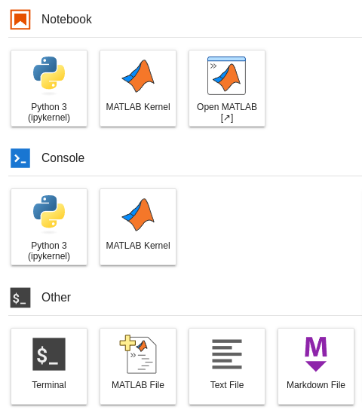 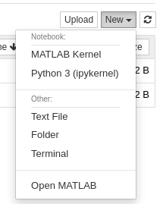

To find out more about the MATLAB Integration for Jupyter:

* <https://github.com/mathworks/jupyter-matlab-proxy>
* <https://www.mathworks.com/products/reference-architectures/jupyter.html>
* <https://blogs.mathworks.com/matlab/2023/01/30/official-mathworks-matlab-kernel-for-jupyter-released/>

### Visual Studio Code

I adopted VS Code when I discovered that it was supporting Jupyter/IPython Notebook ipynb files.

As any other Integrated Development Environment, VS Code supports writing scripts and executing them in several languages (Python, Javascript, …)

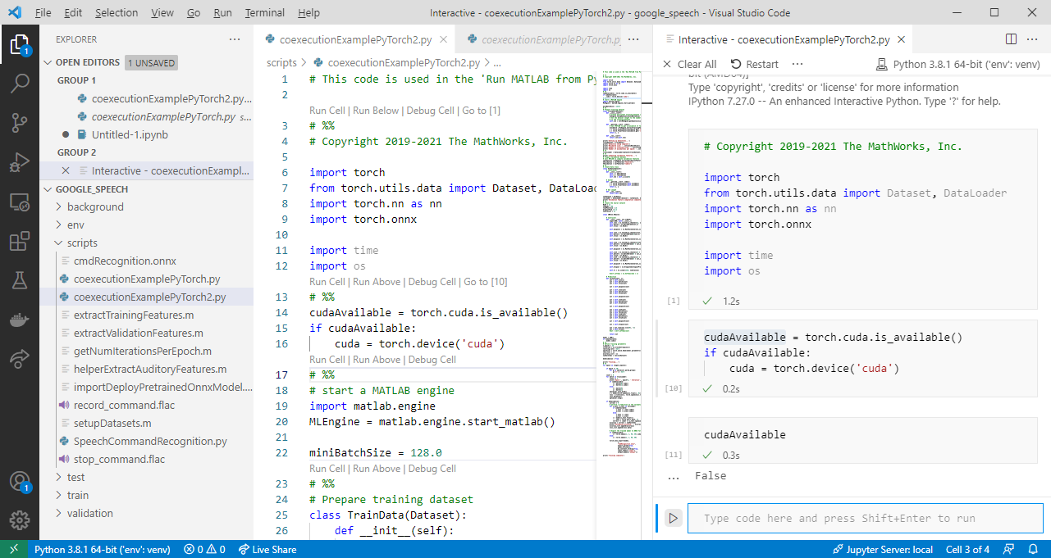

The big difference with the Eclipse[38] approach to componentization is the web standards adopted[39]. This enables to have richer interactions between the development tool and the language server.

And since it is all based on web technologies, you can access a web version at [vscode.dev](https://vscode.dev/). Unlike for web languages like HTML/JS, this does not enable the execution of Python as it would require an interpreter running in the browser, or a server to connect to. Some hacks exist based on Pyodide[40] (a port of Python to WebAssembly).

## Connect MATLAB to Python

You can connect your MATLAB session to Python using the [pyenv](https://www.mathworks.com/help/matlab/ref/pyenv.html) command since 2019b. Before that, use [pyversion](https://www.mathworks.com/help/matlab/ref/pyversion.html) (introduced in 2014b).

If you have multiple Python versions installed, you can specify which version to use, either with:

>> pyenv('Version','3.8')

or

>> pyenv('Version','C:\Users\ydebray\AppData\Local\Programs\Python\  
Python38\python.exe')

This is also the way to connect to Python virtual environments:

>> pyenv('Version','env\Scripts\python.exe')

In your project folder, where you created your virtual environment called env, you simply need to point to the Python executable that is contained in the Scripts subfolder.

**Execution Mode:**

By default, Python runs in the same process as MATLAB. On the plus side, it means that you don’t have overhead for inter-process data exchange between the two systems. But it also means that if Python encounters an error and crashes, then MATLAB crashes as well. This can happen when MATLAB uses different versions of the same library than a given package. For this reason, the *Out-of-Process* execution mode has been introduced[41]:

>> pyenv("ExecutionMode","OutOfProcess")

**Setup Tips:**

* Ensure all code is on path (both on the MATLAB and Python side[42])
* Check environment settings, depending on how you set up Python
* In Out-of-Process Execution, you can terminate the Python process[43]

## Install the MATLAB Engine for Python

Since the MATLAB Engine for Python has been added to the Python Package Index[44] (mid-April 2022), you can simply install it with the pip command:

C:\Users\ydebray>pip install matlabengine

Before that and for release prior to MATLAB R2022a, you had to install in manually[45]:

cd "*matlabroot*\extern\engines\python"

python setup.py install

On Linux, you need to make sure that the default install location of MATLAB by calling matlabroot in a MATLAB Command Window. By default, Linux installs MATLAB at:

/usr/local/MATLAB/R2023a

# Call Python from MATLAB

Why would you want to call Python from MATLAB. There could be a number of reasons.

First, as a single user. You might want to grab features available in Python. For instance, specialized libraries in fields like AI: Machine Learning with Scikit-Learn or XGBoost, Deep-Learning with TensorFlow or PyTorch, Reinforcement Learning with OpenAI Gym, …

Second, if you are working with colleagues that developed Python functions, that you would like to leverage as a MATLAB user, without the need to recode.

Third, if you are deploying your MATLAB Application in a Python-based environment, where some of the services, for instance for data access like in the case of the weather app from the first chapter, are written in Python.

## Execute Python statements and files in MATLAB

Since R2021b, you can run Python statements directly from MATLAB with [pyrun](https://www.mathworks.com/help/matlab/ref/pyrun.html). This is convenient to simply run short snippets of Python code, without having to wrap it into a script.

pyrun("l = [1,2,3]")

pyrun("print(l)")

[1, 2, 3]

As you can see, the pyrun function is stateful, in that it maintains the variable defined in previous calls. You can retrieve the Python variable on the MATLAB side by entering it as a second argument:

pyrun("l2 = [k^2 for k in l]","l2")

ans =

Python list with values:

[3, 0, 1]

Use string, double or cell function to convert to a MATLAB array.

You can retrieve the list of variables defined in the local scope with the function [dir](https://docs.python.org/3/library/functions.html#dir)():

D = pyrun("d = dir()","d")

D =

Python list with values:

['__builtins__', '__name__', 'l', 'l2']

Use string, double or cell function to convert to a MATLAB array.

If it feels more convenient to paste your Python code snippet into a script, you can use [pyrunfile](https://www.mathworks.com/help/matlab/ref/pyrunfile.html).

## Execute Python code in a MATLAB Live Task

Since MATLAB 2022a, you can develop your own custom live tasks. So, in mid-2021, we started prototyping a Python live task with Lucas Garcia. The truth is: I made a first crappy version, and Lucas turned it into something awesome (Lucas should get all the credits for this). Based on this Minimal Viable Product, we engaged with the development teams, both of the MATLAB editor team, and the Python interface team. We decided it would be best to release this prototype in open-source on GitHub to get early feedbacks, and potentially ship it in the product in future version.

The code is available on <https://github.com/mathworks/MATLAB-Live-Task-for-Python>

To test it, just clone or download the repo. Execute the set-up script to register the Live Task in your Task gallery. Create a new Live Script, and select Task in the Live Editor tab. You should see this icon under MY TASKS:

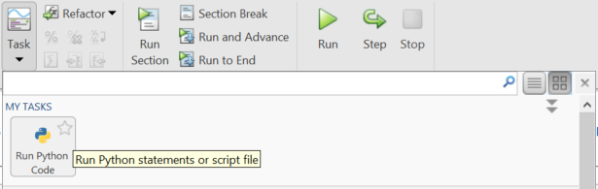

If you click on it, it will add the live task to your Live Script where the cursor is located. Alternatively, you can start typing “python” or “run” directly in your Live Script select the task:

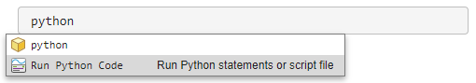

This is what the first version (mine looked like):

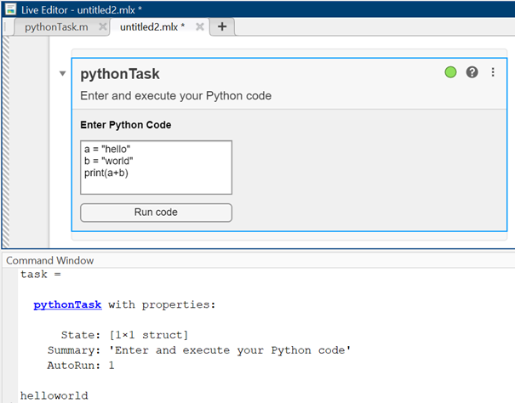

And this is what Lucas turned it into:

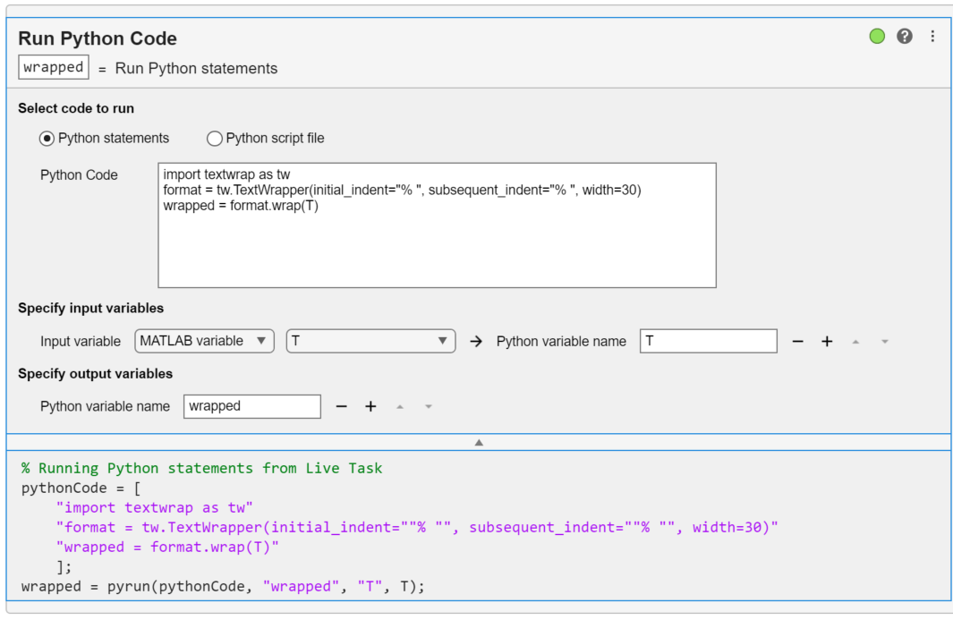

This is meant to be a convenient user interface on top of pyrun. Feel free to share your feedback!

## Basic syntax of calling Python functions from MATLAB

All Python functions in MATLAB have the same basic syntax:

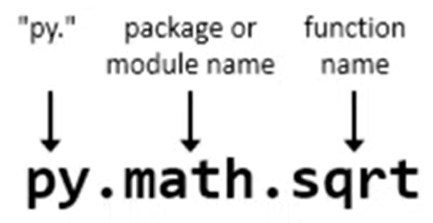

The basic example that I give to kick things off is usually calling the square root function from the math module[46], that is part of the Python standard library. It makes little sense to call mathematics functions in Python from MATLAB, but it is easy to compare the result with what you would expect directly from MATLAB:

In the MATLAB Command Window:

>> py.math.sqrt(42)

In a MATLAB Live Script:

py.math.sqrt(42)

ans = 6.4807

We can create Python data structures from within MATLAB:

py.list([1,2,3])

ans =

Python list with values:

[1.0, 2.0, 3.0]

Use string, double or cell function to convert to a MATLAB array.

py.list({1,2,'a','b'})

ans =

Python list with values:

[1.0, 2.0, 'a', 'b']

Use string, double or cell function to convert to a MATLAB array.

s = struct('a', 1, 'b', 2)

s = *struct with fields:*

a: 1

b: 2

d = py.dict(s)

d =

Python dict with no properties.

{'a': 1.0, 'b': 2.0}

And we can run methods on those data structures from the MATLAB side:

methods(d)

Methods for class py.dict:

char copy eq get items le ne popitem struct values

clear dict ge gt keys lt pop setdefault update

Static methods:

fromkeys

Methods of py.dict inherited from handle.

d.get('a')

ans = 1

## Call Python User Defined Functions from MATLAB

In this chapter, we will leverage a demo developed by a Finance colleague. In this example, he is responsible for building enterprise web predictive analytics that other business critical applications can connect to as a web service. It follows the same structure as the weather example in chapter 2.

This web service is **forecasting the price of cryptocurrencies[47]**: forecast.matlab.com/crypto.js?coin=ETH

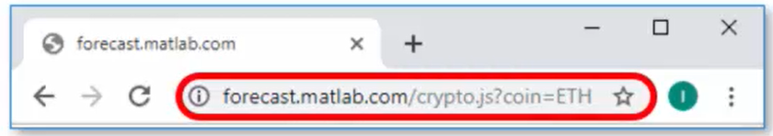

It returns data in the following form (JSON):

[{"Time":"2022-01-21T12:00:00Z","predictedPrice":2466.17},

...

{"Time":"2022-01-21T17:00:00Z","predictedPrice":2442.25}]

The first step is to develop an application that simply shows the historical price movement of a particular cryptocurrency:

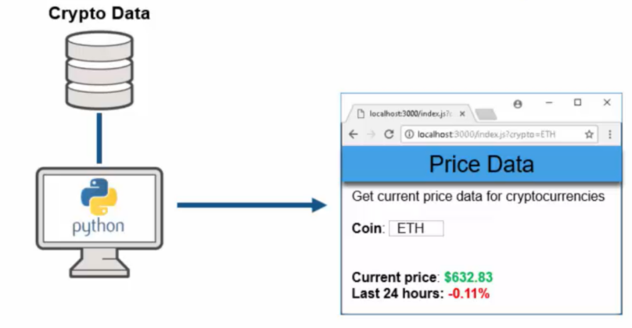

This allows you to monitor the evolution of the price over the last 24 hours and take decisions to buy or sell your crypto assets based on this. Then one day, you manager comes to you and says:

*“Hey, I have an idea. If we had access to the predicted forward-looking data as opposed to the historical data, we could make additional profit beyond what we're currently making, even if the prediction is 100% accurate. “*

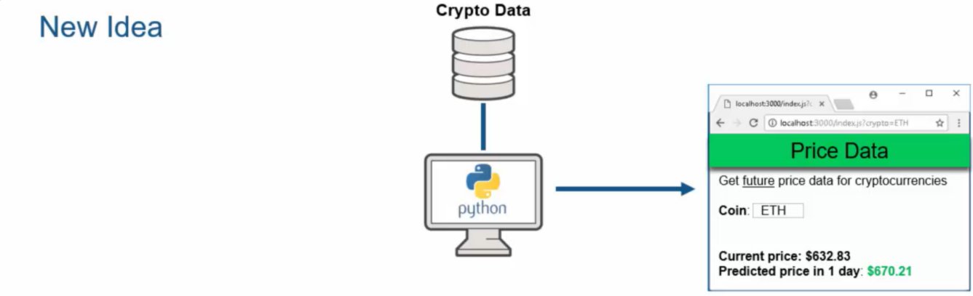

Let’s assume the organization has a few quants that have extensive MATLAB expertise. And they know exactly how to build out such predictive models that the business users are looking for.

However, before we can get to that, our first challenge is to call the Python data scraping libraries and pull that data directly into MATLAB. Our first task at hand: Parse the cryptocurrency URL that we are connecting to, and just get out the domain name. For that, we want to use this function that's contained within the Python standard libraries and use it from within MATLAB. In this case, we are going to call a package urllib[48]. It contains a sub-module called parse, that contains in turn the function urlparse.

startDate = '2022-01-21T12:00:00Z';

stopDate = '2022-01-21T17:00:00Z';

url = "https://api.pro.coinbase.com/products/ETH-USD/candles?start="+startDate+"&end="+stopDate+"&granularity=60";

urlparts = py.urllib.parse.urlparse(url)

urlparts =

Python **ParseResult** with properties:

fragment

hostname

netloc

params

password

path

port

query

scheme

username

ParseResult(scheme='https', netloc='api.pro.coinbase.com', path='/products/ETH-USD/candles', params='', query='start=2022-01-23T01:00:00Z&end=2022-01-23T06:00:00Z&granularity=60', fragment='')

domain = urlparts.netloc

domain =

Python **str** with no properties.

api.pro.coinbase.com

To avoid the unnecessary back and forth of intermediate data between MATLAB and Python, we write a **Python User Defined Module[49]**, called dataLib.py with a few functions in it:

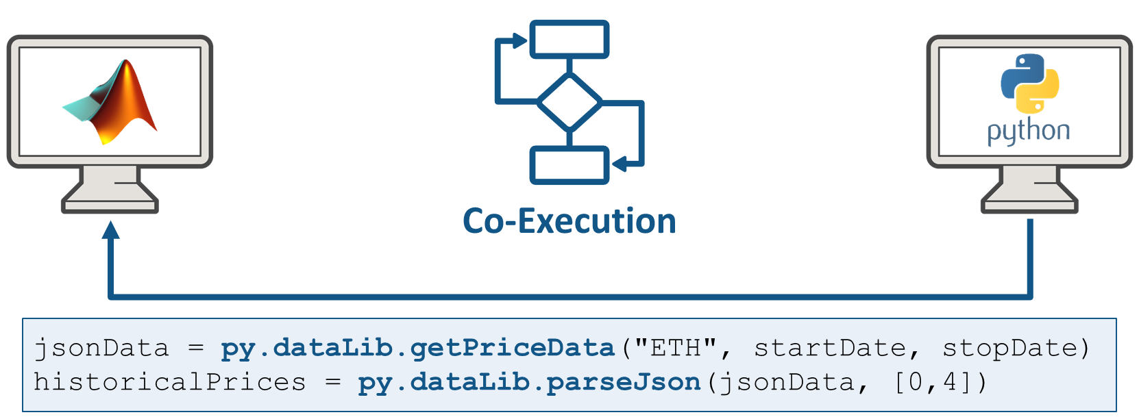

dataLib.py imports 1-minute bars from Coinbase Pro[50]. Note, the API does not fetch the first minute specified by the start date so the times span (start, stop]. To return data we are using a variety of data structures from Numpy arrays to lists and dictionaries, and even JSON.

This is what the function looks like:

def getPriceData(coin, start, stop):

    # returns back a python list containing the historical data

    # of the cryptocurrency 'product' for the period of time

    # ('start', 'stop'].

    import urllib.request

    import json

    import os

    # website we want to pull data from

    hostname = 'api.pro.coinbase.com'

    # all cryptocurrency products returned in USD currency

    product = coin + '-USD'

    # granularity is in seconds, so we are getting 1-minute bars

    granularity = '60'

    # returns back: [date, low, high, open, close, volume]

    url = 'https://' + hostname + '/products/' + product + '/candles?start=' + start + '&end=' + stop + '&granularity=' + granularity

    # execute call to the website

    urlRequest = urllib.request.Request(url, data=None, headers={'User-Agent': 'Mozilla/5.0 (Macintosh; Intel Mac OS X 10_9_3) AppleWebKit/537.36 (KHTML, like Gecko) Chrome/35.0.1916.47 Safari/537.36'})

    response = urllib.request.urlopen(urlRequest)

    html = response.read()

  # python 3.x requires decoding from bytes to string

    data = json.loads(html.decode())

    return data

This is how you would call this function from MATLAB:

product = "ETH";

startDate = '2022-01-21T12:00:00Z';

stopDate = '2022-01-21T17:00:00Z';

jsonData = py.dataLib.getPriceData(product, startDate, stopDate)

jsonData =

Python list with no properties.

[[1642917600, 2466.17, 2473.56, 2468.52, 2469.96, 258.02707836], ...

[1642899660, 2442.25, 2446.79, 2446.77, 2445.17, 276.4743004]]

If you want to add interactivity to your Live Script, you can add so called **Live Controls**[51]. This is helpful to point other people to areas where you may want to change parameters or select things to do scenario analysis.

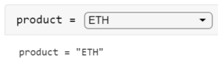

You can insert controls from the ribbon:

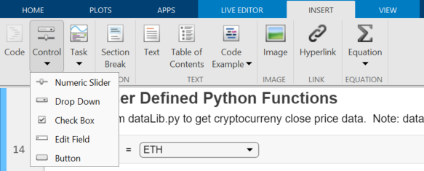

This is how you would parametrize the Live Control:

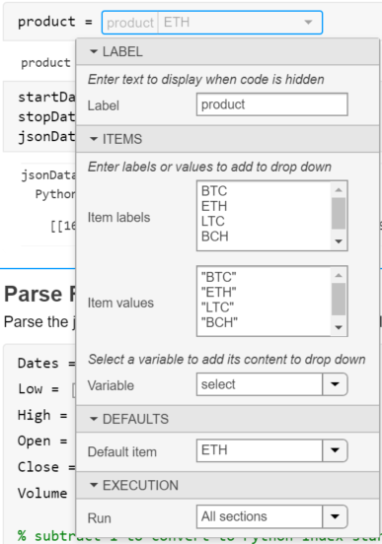

Another type of Live Control that is useful here are simple checkboxes to select the information we want to return from the parseJson function:

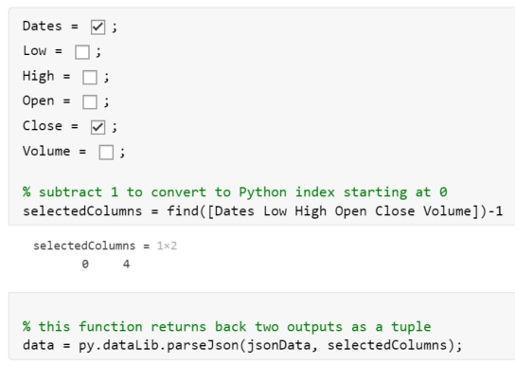

Pay attention to the fact that we are subtracting 1 to the resulting array to adapt to Python indexing starting at 0.

% this function returns back two outputs as a tuple

data = py.dataLib.parseJson(jsonData, selectedColumns);

The last thing we will do in this part of the story is to convert the Python function outputs do MATLAB Data types (this will be covered in the last section of this chapter on mapping data between Python and MATLAB).

In this case, we have a complex tuple that has a Numpy arrays inside of it, as well as a list. We can easily split up the tuple by using syntax like this:

priceData = data{1}

priceData =

Python ndarray:

1.0e+09 *

1.6429 0.0000

1.6429 0.0000  
 ...

1.6429 0.0000

1.6429 0.0000

Use details function to view the properties of the Python object.

Use double function to convert to a MATLAB array.

columnNames = data{2}

columnNames =

Python list with no properties.

['Date', 'Close']

Then we can cast over the Numpy array on the right-hand side by just using the double command:

priceData = double(priceData)

priceData = 300×2

109 ×

1.6429 0.0000

1.6429 0.0000

1.6429 0.0000

1.6429 0.0000

1.6429 0.0000

1.6429 0.0000

1.6429 0.0000

1.6429 0.0000

1.6429 0.0000

1.6429 0.0000

⋮

Likewise, we have a variety of commands for casting lists like string (or cell before R2022a):

columnNames = string(columnNames);

Once we have those data in MATLAB, we will convert it over to the MATLAB table, which is basically equivalent to Pandas data frames:

data = array2table(priceData, 'VariableNames', columnNames);

Like tables, timetable are built-in data constructs that appeared in MATLAB over the last couple of years to make our lives easy for doing simple types of tasks or even complex types of tasks. If I want to deal with time zones and convert the times – which are with respect to universal time zone – to a view of someone who is in New York, the command datetime[52] allows us to do that conversion:

data.Date = datetime(data.Date, 'ConvertFrom', 'posixtime', 'TimeZone', 'America/New_York')

data = 300×2 table

|  | **Date** | **Close** |
| --- | --- | --- |
| **1** | 21-Jan-2022 12:00:00 | 2.8073e+03 |
| **2** | 21-Jan-2022 11:59:00 | 2.8108e+03 |
| **3** | 21-Jan-2022 11:58:00 | 2.8051e+03 |
| **4** | 21-Jan-2022 11:57:00 | 2.8071e+03 |
| **5** | 21-Jan-2022 11:56:00 | 2.8051e+03 |

⋮

plot(data.Date, data.Close)



**Reload Modified User-Defined Python Module[53]**

What if you’ve made modifications to the functions inside of your dataLib module? You call those again from MATLAB, but you don’t see any difference. It is because you need to reload the module:

mod = py.importlib.import_module('dataLib');

py.importlib.reload(mod);

You may need to unload the module first, by clearing the classes. This will delete all variables, scripts and classes in your MATLAB workspace.

clear classes

If you’re running Python out-of-process, another approach is to simply terminate the process[54].

terminate(pyenv)

## Call Python community packages from MATLAB

In some scientific fields like earth and climate sciences, we observe a growing Python community. But as programming skills may vary a lot in researchers and engineers, a MATLAB interface to Python community packages can open up some domain specific capabilities to the 5M+ MATLAB community.

One great example of this is the Climate Data Store Toolbox[55] developed by Rob Purser, a fellow MathWorker. Rob and I are part of the MathWorks Open Source Program. We are promoting open-source, both to support the use of open-source software in MathWorks products and to help for MathWorkers to contribute their work on GitHub and the MATLAB File Exchange[56].

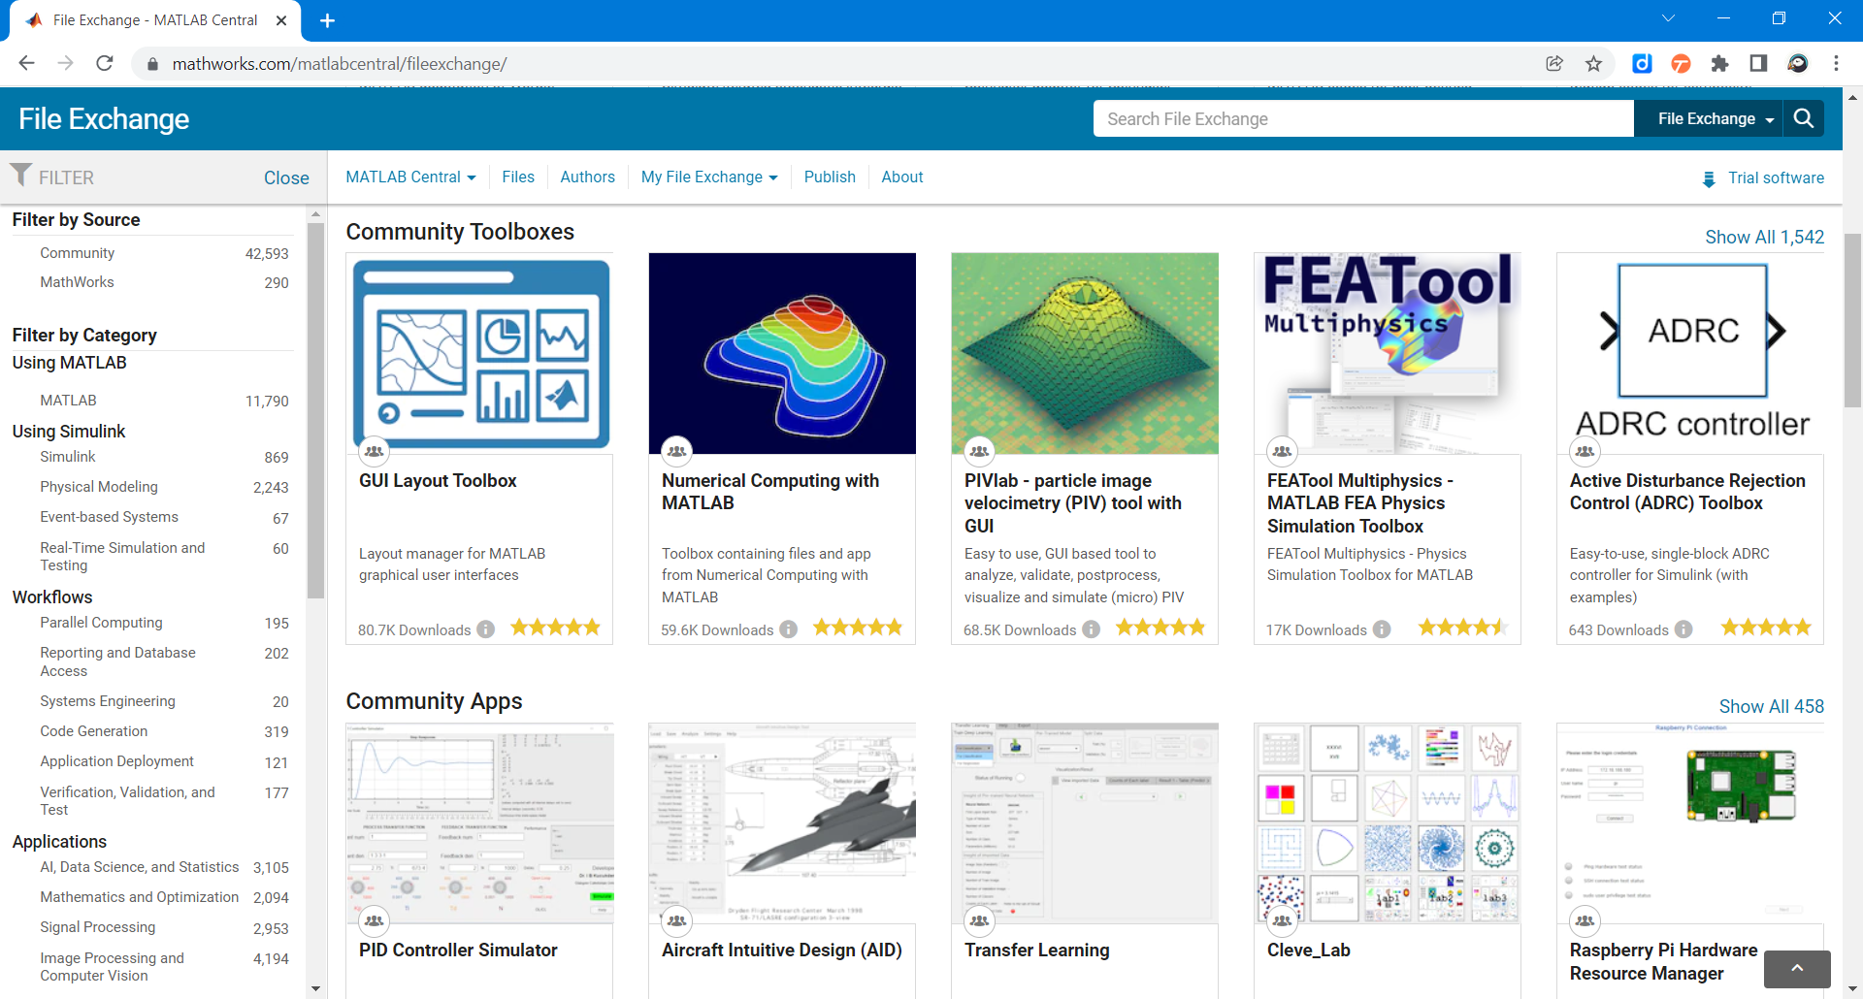

In this section we will demonstrate with the Climate Data Store Toolbox how to build MATLAB toolboxes on top of Python packages. It relies on the CDS Python API[57] created by the European Centre for Medium-Range Weather Forecasts (ECMWF). The toolbox will automatically configure Python, download and install the CDSAPI package (you can manually do it using pip install cdsapi). You will need to create an account on <https://cds.climate.copernicus.eu/> to retrieve data.

The first time you use it, it will prompt you for CSAPI credentials.

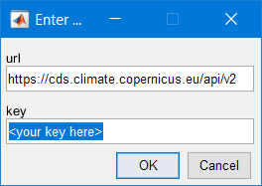

A well written toolbox like this one throwing an error coming from Python will forward this error:

datasetName ="satellite-sea-ice-thickness";

options.version = "1_0";

options.variable = "all";

options.satellite = "cryosat_2";

options.cdr_type = ["cdr","icdr"];

options.year = ["2011","2021"];

options.month = "03";

[downloadedFilePaths,citation] = climateDataStoreDownload('satellite-sea-ice-thickness',options);

2022-01-20 19:33:13,558 INFO Welcome to the CDS

2022-01-20 19:33:13,577 INFO Sending request to https://cds.climate.copernicus.eu/api/v2/resources/satellite-sea-ice-thickness

Error using api>_api  
Python Error: Exception: Client has not agreed to the required terms and conditions.. To access this resource, you first need to accept the  
termsof 'Licence to use Copernicus Products' at https://cds.climate.copernicus.eu/cdsapp/#!/terms/licence-to-use-copernicus-products

Error in api>retrieve (line 348)  
  
Error in climateDataStoreDownload (line 60)  
 retrieveFromCDS(name,options,zipfilePath);

This error for instance indicates that an exception has been raised on the Python side.

In this case the culprit is located in the following MATLAB function:

function retrieveFromCDS(name,options,zipfilePath)

% Utility function to isolate python code so that we don't trigger the

% python check until after python install checks are done.

% Copyright 2021 The MathWorks, Inc.

c = py.cdsapi.Client();

% Don't show the progress information

c.quiet = true;

c.progress = false;

c.retrieve(name,options,zipfilePath);

end

Once imported with Python, the NetCDF files are read with MATLAB using ncread[58] and storing information as timetable[59] with the function readSatelliteSeeIceThickness[60]:

ice2011 = readSatelliteSeaIceThickness("satellite-sea-ice-thickness\ice_thickness_nh_ease2-250_cdr-v1p0_201103.nc");

ice2021 = readSatelliteSeaIceThickness("satellite-sea-ice-thickness\ice_thickness_nh_ease2-250_icdr-v1p0_202103.nc");

head(ice2021)

ans = 8×3 timetable

|  | **time** | **lat** | **lon** | **thickness** |
| --- | --- | --- | --- | --- |
| **1** | 01-Mar-2021 | 47.6290 | 144.0296 | 2.4566 |
| **2** | 01-Mar-2021 | 47.9655 | 144.0990 | 2.5800 |
| **3** | 01-Mar-2021 | 50.5072 | 148.0122 | -0.0364 |
| **4** | 01-Mar-2021 | 50.8360 | 148.1187 | 1.0242 |
| **5** | 01-Mar-2021 | 50.3237 | 146.9969 | 0.0518 |
| **6** | 01-Mar-2021 | 51.1642 | 148.2269 | 0.2445 |
| **7** | 01-Mar-2021 | 50.9112 | 147.6573 | 0.8933 |
| **8** | 01-Mar-2021 | 50.6540 | 147.0948 | 0.1271 |

disp(citation)

Generated using Copernicus Climate Change Service information 2022

This toolbox leverages the beautiful geoplotting[61] capabilities of MATLAB:

subplot(1,2,1)

geodensityplot(ice2011.lat,ice2011.lon,ice2011.thickness,"FaceColor","interp")

geolimits([23 85],[-181.4 16.4])

geobasemap("grayterrain")

title("Ice Thickness, March 2011")

subplot(1,2,2)

geodensityplot(ice2021.lat,ice2021.lon,ice2021.thickness,"FaceColor","interp")

geolimits([23 85],[-181.4 16.4])

geobasemap("grayterrain")

title("Ice Thickness, March 2021")

f = gcf;

f.Position(3) = f.Position(3)*2;

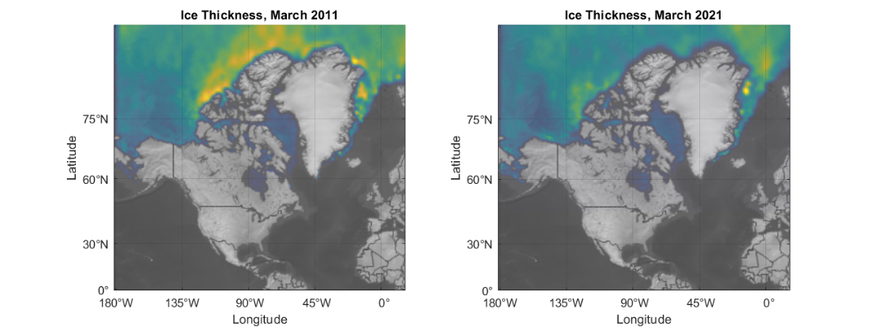

In a well written toolbox like this one, you find a documentation that is packaged directly with it.

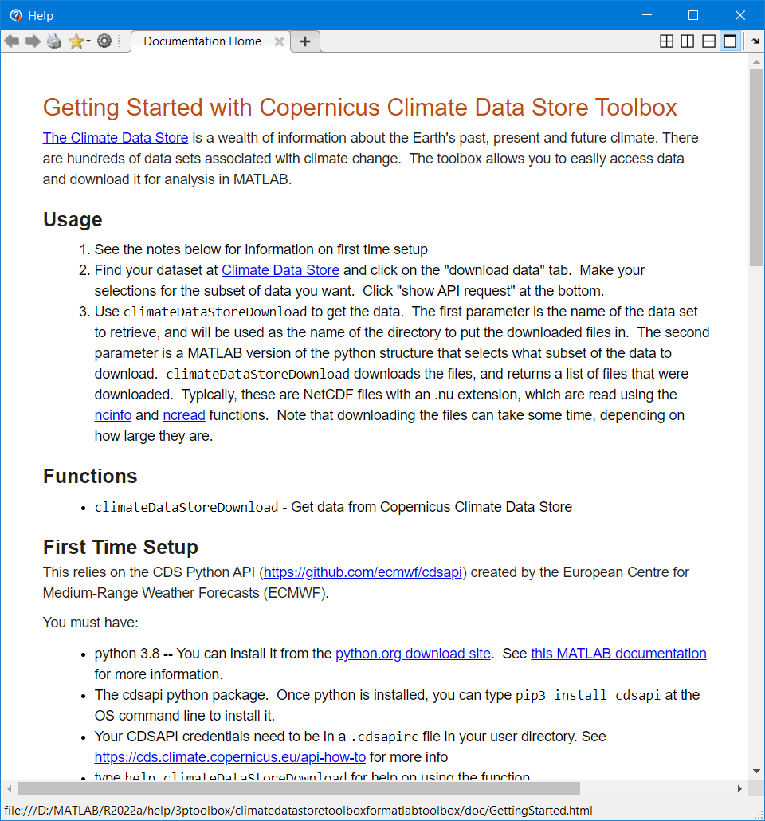

You can create your own toolbox and share it with others. These files can include MATLAB code, data, apps, examples, and documentation. When you create a toolbox, MATLAB generates a single installation file (.mltbx) that enables you or others to install your toolbox.

Read more on how to create and share toolboxes[62]

## Debug Python code called by MATLAB

One of the first difficulty you will face when developing bilingual applications, is debugging across the language boundary. In the following examples we will demonstrate how to attach a MATLAB session to a VSCode or Visual Studio process to debug the Python part of your app. In the next chapter, we will see how to do the opposite, debug the MATLAB part with the nice MATLAB Debugger.

### Debug with Visual Studio Code

This section is showing in 8 steps how to debug Python code called from MATLAB with VSCode[63]:

1. Install VS Code and create a project.

See the official tutorial[64] for instructions on how to install Visual Studio Code, set up a Python project, select a Python interpreter, and create a launch.json file.

2. In a terminal, install the debugpy module using, for example,

$ python -m pip install debugpy

3. In VS Code, add the following debugging code to the top of your Python module.

import debugpy

debugpy.debug_this_thread()

4. Configure the launch.json file to select and attach to MATLAB using the code below.

{

    "version": "0.2.0",

    "configurations": [

         {

            "name": "Attach to MATLAB",

            "type": "python",

            "request": "attach",

            "processId": "${command:pickProcess}"

        }

    ]

}

5. Add breakpoints to your code.

6. Set up your Python environment in MATLAB and get the ProcessID number. In this example, the ExecutionMode is set to InProcess.

>> pyenv

ans =

  PythonEnvironment with properties:

          Version: "3.9"

       Executable: "C:\Users\username\AppData\Local\Programs\Python\Python39\python.exe"

          Library: "C:\Users\username\AppData\Local\Programs\Python\Python39\python39.dll"

             Home: "C:\Users\username\AppData\Local\Programs\Python\Python39"

           Status: Loaded

    ExecutionMode: InProcess

        ProcessID: "27664"

      ProcessName: "MATLAB"

If you see Status: NotLoaded, execute any Python command to load the Python interpreter (for example  >> py.list )  then execute the pyenv command to get the ProcessID for the MATLAB process.

7. Attach the MATLAB process to VS Code.

In VS Code, select "Run and Debug" (Ctrl+Shift+D), then select the arrow to Start Debugging (F5). In this example, the green arrow has the label "Attach to MATLAB". Note that this corresponds to the value of the "name" parameter that you specified in the launch.json file. Type "matlab" in the search bar of the dropdown menu and select the "MATLAB.exe" process that matches the ProcessID from the output of the pyenv command. Note that if you are using OutOfProcess execution mode, you will need to search for a "MATLABPyHost.exe" process.

**In-process:**

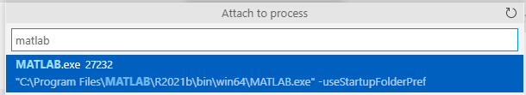

**Out-of-Process:**

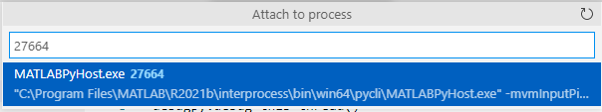

8. Invoke the Python function from MATLAB. Execution should stop at the breakpoint.

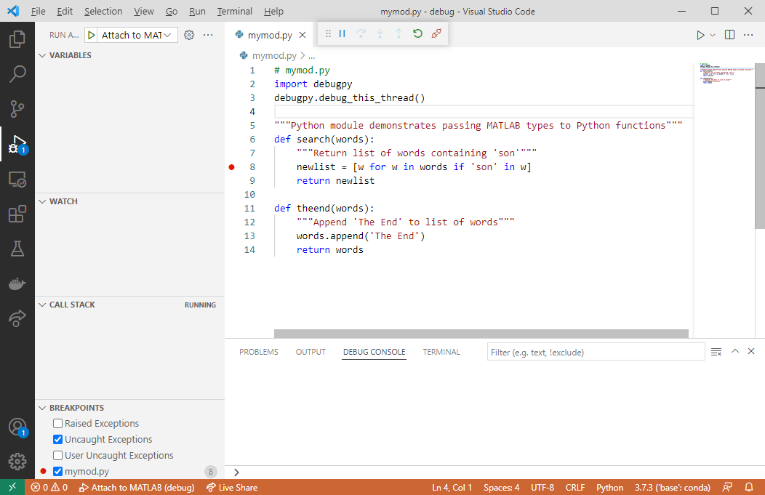

Run the following MATLAB code to step into the Python function search:

>> N = py.list({'Jones','Johnson','James'})

>> py.mymod.search(N)

### Debug with Visual Studio

If you have access to Visual Studio and you are more familiar with it, you can do the same as before with Visual Studio[65]. Open Visual Studio and create a new Python project from existing code. Then, select Attach to Process from the Debug menu:

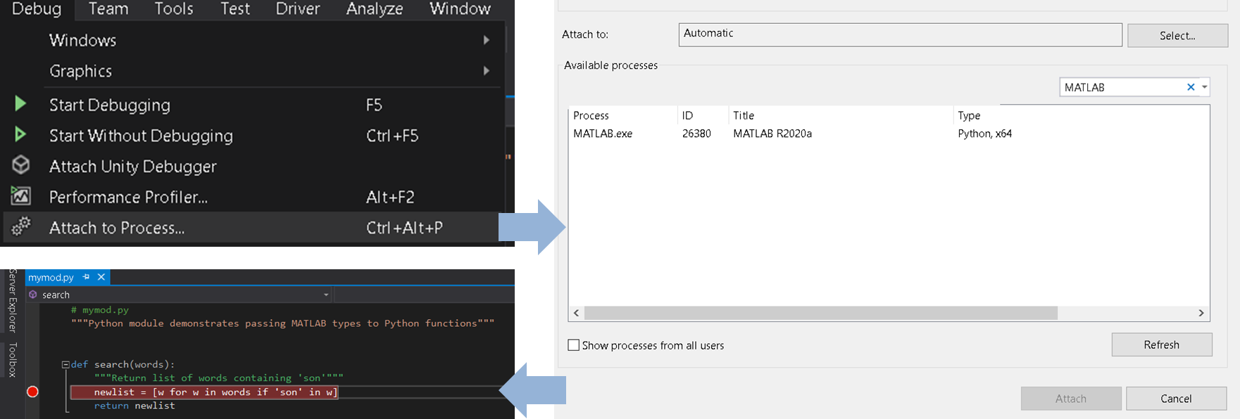

## Mapping data between Python and MATLAB

In his book about *Python for MATLAB Development[66]*, Albert Danial shares some clever functions to convert MATLAB variables into an equivalent Python-native variable with mat2py[67], and vice-versa with py2mat[68].

Converting data[69] returned by Python function inside of MATLAB may require understanding some of the differences in the native datatypes of the two languages:

* Scalars (integers, floating point numbers, …), text and Booleans
* Dictionaries and lists
* Arrays and dataframes

Some specialized MATLAB data types like *timetable* or *categorical* will require some extra love and need to be converted manually. Of course, we can still use these data types in our functions, but the functions need to return types that the Python interpreter can understand.

### Scalars

The table below shows the mappings for common scalar data types:

|  |  |
| --- | --- |
| MATLAB | Python |
| double, single | float |
| complex single, complex double | complex |
| (u)int8, (u)int16, (u)int32, (u)int64 | int |
| NaN | float(nan) |
| Inf | float(inf) |
| string, char | str |
| logical | bool |

By default, numbers in MATLAB are double, whereas numbers without decimal point in Python are integers.

a = py.dataExchange.get_float()

a = 1

class(a)

ans = 'double'

b = py.dataExchange.get_complex()

b = 2.0000 + 0.0000i

class(b)

ans = 'double'

There are several kinds of integers in MATLAB, depending on the precision you require.

For instance [uint8](https://www.mathworks.com/help/matlab/ref/uint8.html) can only store positive numbers between 0 and 255, whereas [int8](https://www.mathworks.com/help/matlab/ref/int8.html) covers the range [-27,27-1]. The most generic type to convert Python integers are int64, which you can do explicitly.

c = py.dataExchange.get_integer()

c =

Python int with properties:

denominator: [1×1 py.int]

imag: [1×1 py.int]

numerator: [1×1 py.int]

real: [1×1 py.int]

3

class(c)

ans = 'py.int'

int64(c)

ans = int64

3

When getting a string from a Python function, the convertion isn't obvious. It can either be turned into a [char](https://www.mathworks.com/help/matlab/ref/char.html) (character array) or a [string](https://www.mathworks.com/help/matlab/ref/string.html). You can distinguish them by the single quotation marks for chars, and double quotes for strings.

abc = py.dataExchange.get_string()

abc =

Python str with no properties.

abc

char(abc)

ans = 'abc'

class(char(abc))

ans = 'char'

string(abc)

ans = "abc"

class(string(abc))

ans = 'string'

Finally, the last basic datatype that contains a logical information is called a boolean in Python:

py.dataExchange.get_boolean()

ans = *logical*

1

### Dictionaries and Lists

This is how containers map to each other between the two languages:

|  |  |
| --- | --- |
| MATLAB | Python |
| structure | dict |
| cell arrays | list, tuple |

To illustrate the conversion of Python dictionaries and lists into MATLAB containers, we will reuse the example from chapter 2. JSON data are really close to dictionaries in Python, which makes the data processing very easy when accessing data from web services.

url= webread("https://samples.openweathermap.org").products.current_weather.samples{1};

r = py.urllib.request.urlopen(url).read();

json_data = py.json.loads(r);

py.weather.parse_current_json(json_data)

ans =

Python dict with no properties.

{'temp': 280.32, 'pressure': 1012, 'humidity': 81, 'temp_min': 279.15, 'temp_max': 281.15, 'speed': 4.1, 'deg': 80, 'lon': -0.13, 'lat': 51.51, 'city': 'London', 'current_time': '2022-05-22 22:15:18.161296'}

Dictionaries can contain scalars, but also other datatypes like lists.

url2 = webread("https://samples.openweathermap.org").products.forecast_5days.samples{1};

r2 = py.urllib.request.urlopen(url2).read();

json_data2 = py.json.loads(r2);

forecast = struct(py.weather.parse_forecast_json(json_data2))

forecast = *struct with fields:*

current_time: [1×40 py.list]

temp: [1×40 py.list]

deg: [1×40 py.list]

speed: [1×40 py.list]

humidity: [1×40 py.list]

pressure: [1×40 py.list]

forecastTemp = forecast.temp;

forecastTime = forecast.current_time;

Lists containing only numeric data can be converted into doubles since MATLAB R2022a:

double(forecastTemp)

ans = 1×40

261.4500 261.4100 261.7600 261.4600 260.9810 262.3080 263.7600 ⋯

And any lists can be converted to string (even those containing a mix of text and numeric data).

forecastTimeString = string(forecastTime);

datetime(forecastTimeString)

ans = 1×40 datetime

30-Jan-2017 18:00:0030-Jan-2017 21:00:0031-Jan-2017 00:00:0031-Jan-2017 03:00: ⋯

Before MATLAB R2022a, Python lists need to be converted into MATLAB cell arrays[70]. Cells can then be transformed to double, strings, with the cellfun[71] function. The previous code would look like this until R2021b:

forecastTempCell = cell(forecastTemp)

forecastTempCell = 1×40 cell

|  | **1** | **2** | **3** | **4** | **5** | **6** | **7** | **⋯** |
| --- | --- | --- | --- | --- | --- | --- | --- | --- |
| **1** | 261.4500 | 261.4100 | 261.7600 | 261.4600 | 260.9810 | 262.3080 | 263.7600 |  |

cellfun(@double,forecastTempCell)

ans = 1×40

261.4500 261.4100 261.7600 261.4600 260.9810 262.3080 263.7600 ⋯

forecastTimeCell = cell(forecastTime)

forecastTimeCell = 1×40 cell

|  | **1** | **2** | **3** | **4** | **5** | **6** | **7** | **⋯** |
| --- | --- | --- | --- | --- | --- | --- | --- | --- |
| **1** | 1×19 str | 1×19 str | 1×19 str | 1×19 str | 1×19 str | 1×19 str | 1×19 str |  |

cellfun(@string,forecastTimeCell)

ans = 1×40 string

"2017-01-30 18:0… "2017-01-30 21:0… "2017-01-31 00:0… "2017-01-31 03:0… "2 ⋯

### Arrays

By modifying the parse_forecast_json function in the weather module, we output Python arrays[72] instead of lists. There exists indeed a native array datatype in base Python.

forecast2 = struct(py.weather.parse_forecast_json2(json_data2))

forecast2 = *struct with fields:*

current_time: [1×40 py.list]

temp: [1×1 py.array.array]

deg: [1×1 py.array.array]

speed: [1×1 py.array.array]

humidity: [1×1 py.array.array]

pressure: [1×1 py.array.array]

The MATLAB double function will convert the Python array into a MATLAB array

double(forecast2.temp)

ans = 1×40

261.4500 261.4100 261.7600 261.4600 260.9810 262.3080 263.7600 ⋯

Those data conversion also apply to Numpy arrays:

npA = py.numpy.array([1,2,3;4,5,6;7,8,9])

npA =

Python ndarray:

1 2 3

4 5 6

7 8 9

Use details function to view the properties of the Python object.

Use double function to convert to a MATLAB array.

double(npA)

ans = 3×3

1 2 3

4 5 6

7 8 9

### Dataframes

One common question on data transfer, is how to exchange data between MATLAB tables and Pandas Dataframes. The recommended solution for that is to rely on Parquet files[73]. Parquet is a columnar storage format that enables to store & transfer tabular data between languages. It is available to any project in the Hadoop big data ecosystem, regardless of the choice of data processing framework, data model or programming language (more on Parquet[74]).

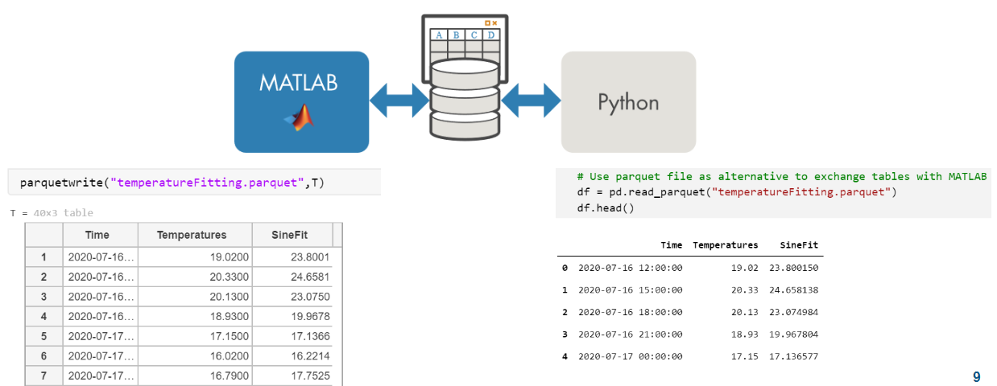

This example demonstrates a back and forth between Pandas DataFrames and MATLAB Tables:

**pq_CreateDataframe.py**

import pandas as pd

import numpy as np

# create dataframe

df = pd.DataFrame({'column1': [-1, np.nan, 2.5],

'column2': ['foo', 'bar', 'tree'],

'column3': [True, False, True]})

print(df)

# save dataframe to parquet file via pyarrow library

df.to_parquet('data.parquet', index=False)

Read in parquet file

% info = parquetinfo('data.parquet')

data = parquetread('data.parquet')

data = 3×3 table

|  | **column1** | **column2** | **column3** |
| --- | --- | --- | --- |
| **1** | -1 | "foo" | 1 |
| **2** | NaN | "bar" | 0 |
| **3** | 2.5000 | "tree" | 1 |

Examine datatype of a particular column

class(data.column2)

ans = 'string'

Change data in table

data.column2 = ["orange"; "apple"; "banana"];

Write the results back to parquet

parquetwrite('newdata.parquet', data)

Finally read the modified DataFrame back in Python:

**pq_ReadTable.py**

import pandas as pd

# read parquet file via pyarrow library

df = pd.read_parquet('newdata.parquet')

print(df)

# Call Python AI libraries from MATLAB

In this Chapter we will look at different Python libraries for Artificial Intelligence, both Machine Learning & Deep Learning (like Scikit-learn and TensorFlow) and how to call them from MATLAB.

Those steps can be integrated in a typical AI workflow[75]:



## Call Scikit-learn from MATLAB

The Iris flower dataset[76] is a multivariate data set introduced by the British statistician and biologist Ronald Fisher. This data set consists of 3 different types of irises’ (Setosa, Versicolour, and Virginica) petal and sepal length, stored in a 150x4 numpy.ndarray. The rows being the samples and the columns being: Sepal Length, Sepal Width, Petal Length and Petal Width.

You can also find this dataset in MATLAB, as it is shipped with a list of Sample Data Sets[77]:

load fisheriris.mat

gscatter(meas(:,1),meas(:,2),species)

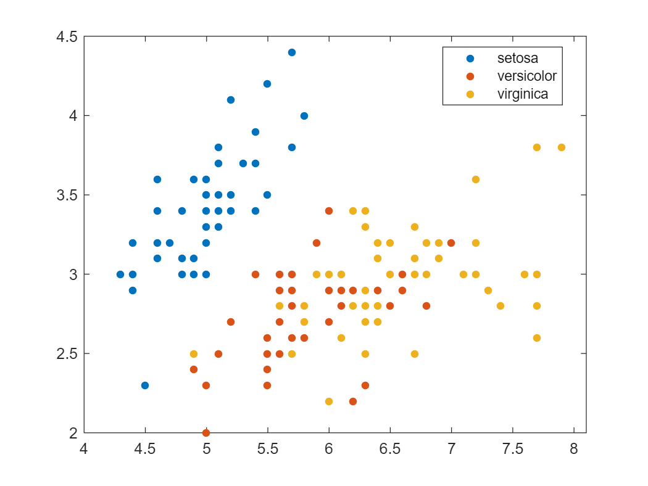

Or retrieve the dataset from the Scikit-learn library[78] (inside of MATLAB still):

iris_dataset = py.sklearn.datasets.load_iris()

iris_dataset =

Python [**Bunch**](matlab:helpPopup%20py.sklearn.utils.Bunch) with no properties.

{'data': array([[5.1, 3.5, 1.4, 0.2],

[4.9, 3. , 1.4, 0.2],

[4.7, 3.2, 1.3, 0.2],

[4.6, 3.1, 1.5, 0.2],

[5. , 3.6, 1.4, 0.2],

[5.4, 3.9, 1.7, 0.4],

...

[6.2, 3.4, 5.4, 2.3],

[5.9, 3. , 5.1, 1.8]]),

'target': array([0, 0, 0, 0, 0, 0, 0, 0, 0, 0, 0, 0, 0, 0, 0, 0, 0, 0, 0, 0, 0, 0,

0, 0, 0, 0, 0, 0, 0, 0, 0, 0, 0, 0, 0, 0, 0, 0, 0, 0, 0, 0, 0, 0,

0, 0, 0, 0, 0, 0, 1, 1, 1, 1, 1, 1, 1, 1, 1, 1, 1, 1, 1, 1, 1, 1,

1, 1, 1, 1, 1, 1, 1, 1, 1, 1, 1, 1, 1, 1, 1, 1, 1, 1, 1, 1, 1, 1,

1, 1, 1, 1, 1, 1, 1, 1, 1, 1, 1, 1, 2, 2, 2, 2, 2, 2, 2, 2, 2, 2,

2, 2, 2, 2, 2, 2, 2, 2, 2, 2, 2, 2, 2, 2, 2, 2, 2, 2, 2, 2, 2, 2,

2, 2, 2, 2, 2, 2, 2, 2, 2, 2, 2, 2, 2, 2, 2, 2, 2, 2]), 'frame': None, 'target_names': array(['setosa', 'versicolor', 'virginica'], dtype='<U10'), 'DESCR': ...

Scikit-learn datasets are returned as a “Bunch object”. You can access the Python modules documentation directly from within MATLAB:

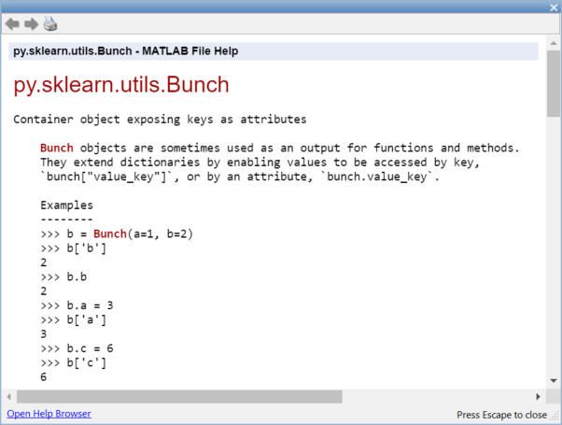

This dataset can be passed to MATLAB as a struct:

struct(iris_dataset)

ans = *struct with fields:*

data: [1×1 py.numpy.ndarray]

target: [1×1 py.numpy.ndarray]

frame: [1×1 py.NoneType]

target_names: [1×1 py.numpy.ndarray]

DESCR: [1×2782 py.str]

feature_names: [1×4 py.list]

filename: [1×8 py.str]

data_module: [1×21 py.str]

The data manipulated in this dataset are by default stored as Numpy arrays.  
Read more on how to Pass Matrices and Multidimensional Arrays to Python[79]

X_np = iris_dataset{'data'}

X_np =

Python [**ndarray**](matlab:helpPopup%20py.numpy.ndarray):

5.1000 3.5000 1.4000 0.2000

4.9000 3.0000 1.4000 0.2000

4.7000 3.2000 1.3000 0.2000

...

Use details function to view the properties of the Python object.

Use double function to convert to a MATLAB array.

X_ml = double(X_np);

X = X_ml(:,1:2)

X = 150×2

5.1000 3.5000

4.9000 3.0000

4.7000 3.2000

4.6000 3.1000

5.0000 3.6000

5.4000 3.9000

4.6000 3.4000

5.0000 3.4000

4.4000 2.9000

4.9000 3.1000

⋮

y = iris_dataset{'target'}

y =

Python [**ndarray**](matlab:helpPopup%20py.numpy.ndarray):

0 0 0 0 0 0 0 0 0 0 0 0 0 0 0 0 0 0 0 0 0 0 0 0 0 0 0 0 0 0 0 0 0 0 0 0 0 0 0 0 0 0 0 0 0 0 0 0 0 0 1 1 1 1 1 1 1 1 1 1 1 1 1 1 1 1 1 1 1 1 1 1 1 1 1 1 1 1 1 1 1 1 1 1 1 1 1 1 1 1 1 1 1 1 1 1 1 1 1 1 2 2 2 2 2 2 2 2 2 2 2 2 2 2 2 2 2 2 2 2 2 2 2 2 2 2 2 2 2 2 2 2 2 2 2 2 2 2 2 2 2 2 2 2 2 2 2 2 2 2

Use [**details**](matlab:helpPopup%20details) function to view the properties of the Python object.

Use [**int64**](matlab:helpPopup%20int64) function to convert to a MATLAB array.

We won’t translate the Python ndarray into a MATLAB datatype just yet, as we will use a cool feature of Python to translate the list of ordinal values into a list of categorical species. Those features can be leveraged in MATLAB with a few calls to pyrun[80]

pyrun('dict = {0: "setosa",1: "versicolor", 2: "virginica"}')

% pass y as input, and retrieve species as output

s = pyrun('species = [dict[i] for i in y]','species',y = y)

s =

Python [**list**](matlab:helpPopup%20py.list) with no properties.

['setosa', 'setosa', 'setosa', 'setosa', 'setosa', 'setosa', 'setosa', 'setosa', ...

Finally, you can retrieve the Python list as a [MATLAB categorical](https://www.mathworks.com/help/matlab/categorical-arrays.html) variable:

s = string(s);

species = categorical(s)

species = *1×150 categorical array*

setosa setosa setosa setosa setosa setosa setosa ...

Another approach for the preprocessing in Python can be performed with [pyrunfile](https://www.mathworks.com/help/matlab/ref/pyrunfile.html)

[X,y,species] = pyrunfile('iris_data.py',{'Xl','y','species'})

X =

Python [**list**](matlab:helpPopup%20py.list) with no properties.

[[5.1, 3.5], [4.9, 3.0], [4.7, 3.2], [4.6, 3.1], [5.0, 3.6], [5.4, 3.9], [4.6, 3.4],...

y =

Python [**ndarray**](matlab:helpPopup%20py.numpy.ndarray):

0 0 0 0 0 0 0 0 0 0 0 0 0 0 0 0 0 0 0 0 0 0 0 0 0 0 0 0 0 0 0 0 0 0 0 0 0 0 0 0 0 0 0 0 0 0 0 0 0 0 1 1 1 1 1 1 1 1 1 1 1 1 1 1 1 1 1 1 1 1 1 1 1 1 1 1 1 1 1 1 1 1 1 1 1 1 1 1 1 1 1 1 1 1 1 1 1 1 1 1 2 2 2 2 2 2 2 2 2 2 2 2 2 2 2 2 2 2 2 2 2 2 2 2 2 2 2 2 2 2 2 2 2 2 2 2 2 2 2 2 2 2 2 2 2 2 2 2 2 2

Use [**details**](matlab:helpPopup%20details) function to view the properties of the Python object.

Use [**int64**](matlab:helpPopup%20int64) function to convert to a MATLAB array.

species =

Python [**list**](matlab:helpPopup%20py.list) with no properties.

['setosa', 'setosa', 'setosa', 'setosa', 'setosa', 'setosa', 'setosa', 'setosa', ...

This is what the python scripts looks like:

iris_data.py

from sklearn import datasets

iris = datasets.load_iris()

X = iris.data[:, :2]  # we only take the first two features (sepal)

Xl = X.tolist()

y = iris.target

dict = {0: "setosa",1: "versicolor", 2: "virginica"}

species = [dict[i] for i in y]

In this case, we are retrieving a list of lists, instead of a Numpy array. This will require some manual data marshalling:

Xc = cell(X)'

Xc = *150×1 cell array*

{1×2 py.list}

{1×2 py.list}

{1×2 py.list}

{1×2 py.list}

{1×2 py.list}  
 ...

Xc1 = cell(Xc{1})

Xc1 = *1×2 cell array*

{[5.1000]} {[3.5000]}

cell2mat(Xc1)

ans =

5.1000 3.5000

The previous steps are included in the helper function dataprep (at the end of the live script):

function Xp = dataprep(X)

Xc = cell(X)';

Xcc = cellfun(@cell,Xc,'UniformOutput',false);

Xcm = cellfun(@cell2mat,Xcc,'UniformOutput',false);

Xp = cell2mat(Xcm);

end

X_ml = dataprep(X);

y_ml = double(y);

s = string(species);

species = categorical(s);

Call the Scikit-Learn Logistic Regression and its fit and predict methods directly:

model = py.sklearn.linear_model.LogisticRegression();

model = model.fit(X,y); % pass by object reference

y2 = model.predict(X);

y2_ml = double(y2);

confusionchart(y_ml,y2_ml)



Call the Scikit-Learn model through a wrapper module:

model = py.iris_model.train(X,y);

y2 = py.iris_model.predict(model, X)

y2 =

Python ndarray:

0 0 0 0 0 0 0 0 0 0 0 0 0 0 0 0 0 0 0 0 0 0 0 0 0 0 0 0 0 0 0 0 0 0 0 0 0 0 0 0 0 0 0 0 0 0 0 0 0 0 2 2 2 1 2 1 2 1 2 1 1 1 1 1 1 2 1 1 1 1 1 1 1 1 2 2 2 2 1 1 1 1 1 1 1 2 2 1 1 1 1 1 1 1 1 1 1 1 1 1 2 1 2 2 2 2 1 2 2 2 2 2 2 1 1 2 2 2 2 1 2 1 2 1 2 2 1 1 2 2 2 2 2 2 1 2 2 2 1 2 2 2 1 2 2 2 1 2 2 1

Use details function to view the properties of the Python object.

Use int64 function to convert to a MATLAB array.

sum(y_ml == y2)/length(y_ml) % precision of the model based on training set

ans = 0.8200

Alternatively, you can train all sorts of classification models in MATLAB. If you don't feel too comfortable with the various machine learning methods, you can simply try out the results from different types of models with an app:

classificationLearner(X_ml,species)

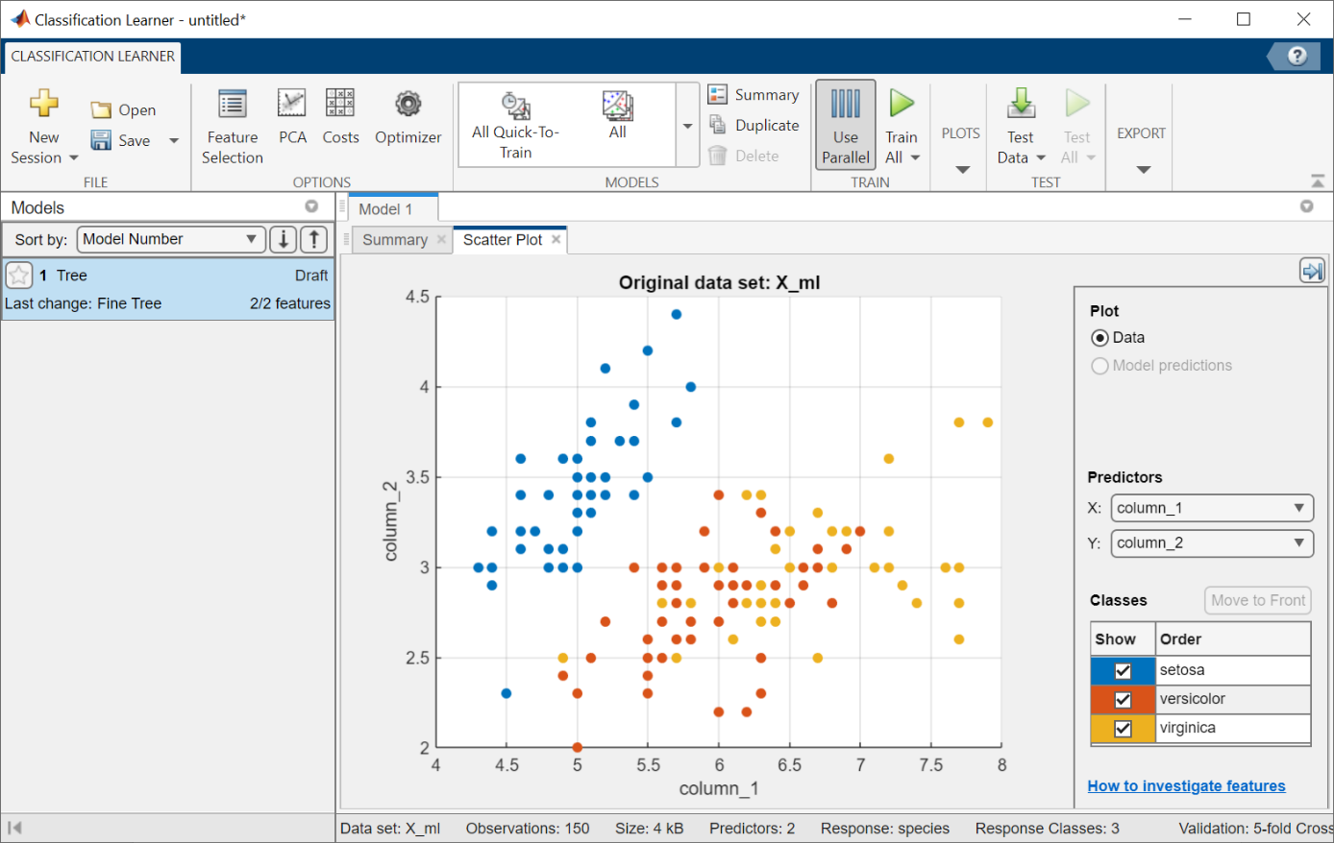

## Diagram Description automatically generatedCall TensorFlow from MATLAB

Let’s introduce the use of Tensorflow with the getting started tutorial[81]:

This guide uses the Fashion MNIST[82] dataset which contains 70,000 grayscale images in 10 categories. The images show individual articles of clothing at low resolution (28 by 28 pixels).

This example is curated by Zalando, under a MIT License.

First let’s **load tensorflow** explicitely, and check the version of tensorflow installed:

tf = py.importlib.import_module('tensorflow');

pyrun('import tensorflow as tf; print(tf.__version__)')

2.8.0

Then let’s **retrieve the dataset**

fashion_mnist = tf.keras.datasets.fashion_mnist;

train_test_tuple = fashion_mnist.load_data();

And store the images and labels for training and testing separately.

Indexing into Python tuples in MATLAB[83] is done with curly brackets: pytuple{1}

(Remember that indexing starts at 1 in MATLAB unlike Python starting at 0)

% ND array containing gray scale images (values from 0 to 255)

train_images = train_test_tuple{1}{1};

test_images = train_test_tuple{2}{1};

% values from 0 to 9: can be converted as uint8

train_labels = train_test_tuple{1}{2};

test_labels = train_test_tuple{2}{2};

Define the list of classes directly in MATLAB:

class_names = ["T-shirt/top", "Trouser", "Pullover", "Dress", "Coat", "Sandal", "Shirt", "Sneaker", "Bag", "Ankle boot"]

class_names = 1×10 string

"T-shirt/top" "Trouser" "Pullover" "Dress" "Coat" "Sandal" ⋯

If we want to use the index of the training labels from the list above in MATLAB, we need to shift the range from [0:9] to [1:10]

tl = uint8(train_labels)+1; % shifting range from [0:9] to [1:10]

l = length(tl)

l = 60000

The following shows there are 60,000 images in the training set, with each image represented as 28 x 28 pixels:

train_images_m = uint8(train_images);

size(train_images_m)

ans = 1×3

60000 28 28

To **resize a single image** from the dataset, use the reshape function:

size(train_images_m(1,:,:))

ans = 1×3

1 28 28

size(reshape(train_images_m(1,:,:),[28,28]))

ans = 1×2

28 28

You can add a live control to your live script to **explore your dataset**:

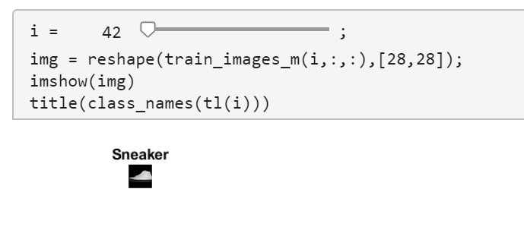i = 42;

img = reshape(train_images_m(i,:,:),[28,28]);

imshow(img)

title(class_names(tl(i)))



You must **preprocess the data** before training the network.

If you inspect the first image in the training set, you will see that the pixel values fall in the range of 0 to 255:

train_images = train_images / 255;

test_images = test_images / 255;

Finally, **build the model** with the function specified in the tf_helper file / module:

model = py.tf_helper.build_model();

You can look at the architecture of the model by retrieving the layers in a cell array:

cell(model.layers)

ans = 1×3 cell

|  | **1** | **2** | **3** |
| --- | --- | --- | --- |
| **1** | 1×1 Flatten | 1×1 Dense | 1×1 Dense |

py.tf_helper.compile_model(model);

py.tf_helper.train_model(model,train_images,train_labels)

Epoch 1/10

1/1875 [..............................] - ETA: 12:59 - loss: 159.1949 - accuracy: 0.2500

39/1875 [..............................] - ETA: 2s - loss: 52.8977 - accuracy: 0.5256

76/1875 [>.............................] - ETA: 2s - loss: 34.8739 - accuracy: 0.6049

113/1875 [>.............................] - ETA: 2s - loss: 28.4213 - accuracy: 0.6350

157/1875 [=>............................] - ETA: 2s - loss: 22.9735 - accuracy: 0.6616

194/1875 [==>...........................] - ETA: 2s - loss: 20.3405 - accuracy: 0.6740

229/1875 [==>...........................] - ETA: 2s - loss: 18.3792 - accuracy: 0.6861

265/1875 [===>..........................] - ETA: 2s - loss: 16.7848 - accuracy: 0.6943

...

**Evaluate the model** by comparing how the model performs on the test dataset:

test_tuple = py.tf_helper.evaluate_model(model,test_images,test_labels)

313/313 - 0s - loss: 0.5592 - accuracy: 0.8086 - 412ms/epoch - 1ms/step

test_tuple =

Python tuple with values:

(0.5592399835586548, 0.8086000084877014)

Use string, double or cell function to convert to a MATLAB array.

test_acc = test_tuple{2}

test_acc = 0.8086

**Test the model** on the first image from the test dataset:

test_images_m = uint8(test_images);

prob = py.tf_helper.test_model(model,py.numpy.array(test_images_m(1,:,:)))

prob =

Python ndarray:

0.0000 0.0000 0.0000 0.0000 0.0000 0.0002 0.0000 0.0033 0.0000 0.9965

Use details function to view the properties of the Python object.

Use single function to convert to a MATLAB array.

[argvalue, argmax] = max(double(prob))

argvalue = 0.9965

argmax = 10

imshow(reshape(test_images_m(1,:,:),[28,28])*255)

title(class_names(argmax))



## Import TensorFlow model into MATLAB

To illustrate the TensorFlow & ONNX import/export capabilities[84], we will take a workflow around an autonomous driving use case.

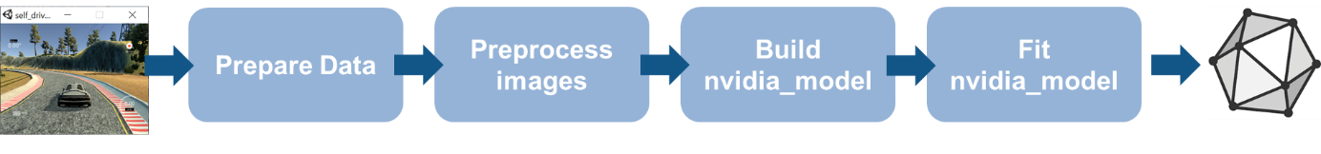

The data is generated by a simple open-source driving simulator[85] from Udacity. And the model comes from a real-life experiment from NVIDIA about End-to-end learning for self-driving cars[86].

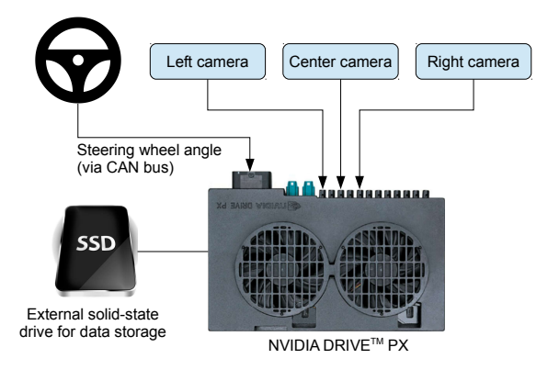 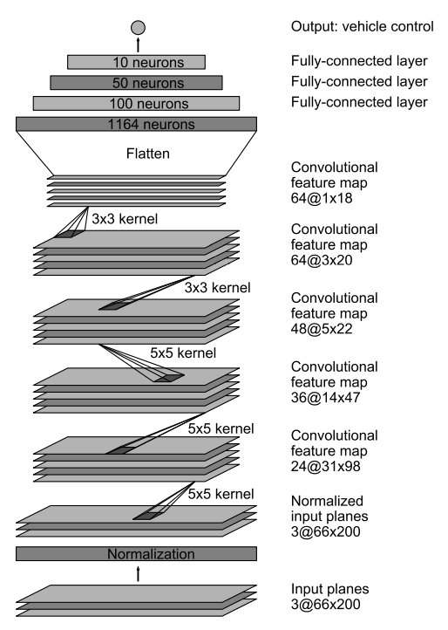

The inputs of the neural network are images from the camera and the output to predict in the steering angle (between -1 and 1). We will simplify the problem with only 5 classes(from left to right).

First, import csv file created by the driving simulator with images locations and steering ground truth:

filename = "driving_log.csv";

drivinglog = import_driving_log( filename );

drivinglog = drivinglog(2:end,:)

drivinglog = 7935×8 table

|  | **VarName1** | **center** | **left** | **⋯** |
| --- | --- | --- | --- | --- |
| **1** | 0 | "center_2021_04_25_11_32_45_622.jpg" | "left_2021_04_25_11_32_45_622.jpg" |  |
| **2** | 1 | "center_2021_04_25_11_32_45_689.jpg" | "left_2021_04_25_11_32_45_689.jpg" |  |
| **3** | 2 | "center_2021_04_25_11_32_45_765.jpg" | "left_2021_04_25_11_32_45_765.jpg" |  |
| **4** | 3 | "center_2021_04_25_11_32_45_834.jpg" | "left_2021_04_25_11_32_45_834.jpg" |  |
| **5** | 4 | "center_2021_04_25_11_32_45_905.jpg" | "left_2021_04_25_11_32_45_905.jpg" |  |
| **⋮** |  |  |  |  |

**Prepare the data**

Analyze the range of values for the steering angle to find the optimal class values.

histogram(drivinglog.steering);

title("Original steering angle distribution");

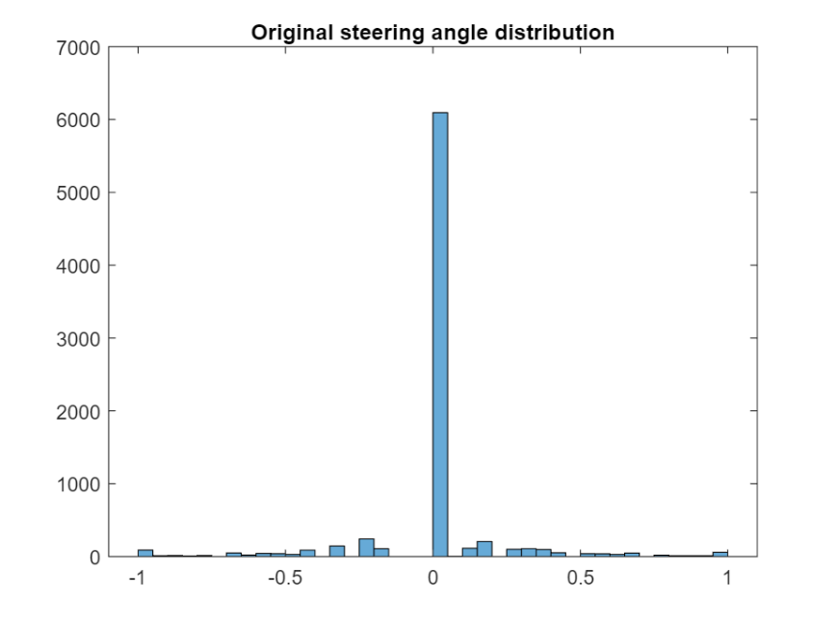

Use discretize to group the steering angles into discrete bins.

steeringLimits = [-1 -0.5 -0.05 0 0.05 0.5 1];

steeringClasses=discretize(drivinglog.steering,steeringLimits,'categorical');

classNames = categories(steeringClasses);

Merge the two bins that represent the angle close to 0 degrees.

steeringClasses=mergecats(steeringClasses,["[-0.05, 0)","[0, 0.05)"], "0.0");

histogramClasses = histogram(steeringClasses);

title("Angle distribution discretized (5 categories)");

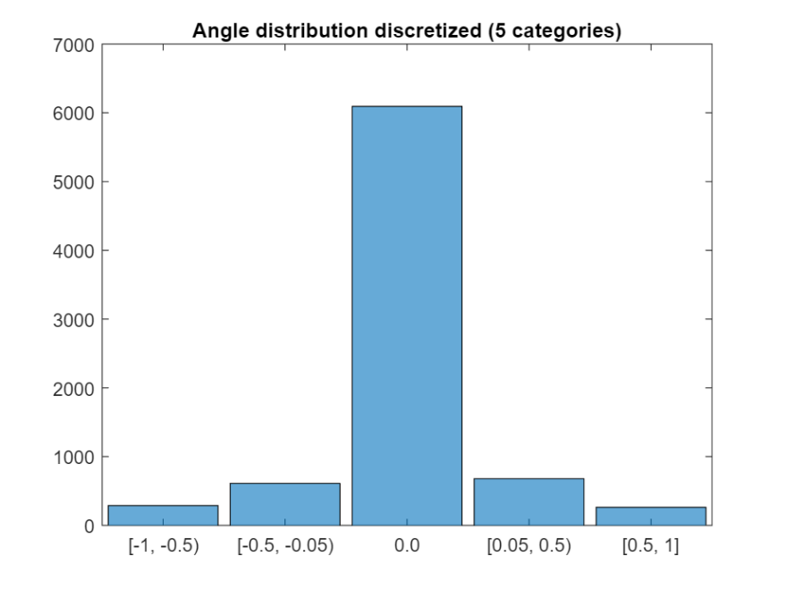

**Create image datastore and balance data (undersampling)**

The previous histogram shows that the dataset is highly unbalanced. Use countEachLabel to check how many instances there are of each class.

imds=imageDatastore("sim_data/"+drivinglog.center,"Labels", steeringClasses);

countEachLabel(imds)

ans = 5×2 table

|  | **Label** | **Count** |
| --- | --- | --- |
| **1** | [-1, -0.5) | 288 |
| **2** | [-0.5, -0.05) | 611 |
| **3** | 0 | 6093 |
| **4** | [0.05, 0.5) | 679 |
| **5** | [0.5, 1] | 264 |

Define how many samples of the unbalanced class should be kept and randomly select these samples.

maxSamples = 800;

countLabel = countEachLabel(imds);

[~, unbalancedLabelIdx] = max(countLabel.Count);

unbalanced = imds.Labels == countLabel.Label(unbalancedLabelIdx);

idx = find(unbalanced);

randomIdx = randperm(numel(idx));

downsampled = idx(randomIdx(1:maxSamples));

retained = [find(~unbalanced) ; downsampled];

imds = subset(imds, retained');

histogram(imds.Labels)



**Separate the dataset into training, validation and testing**

Extract 90% of the data for training and the remaining for testing and validation.

[imdsTrain, imdsValid,imdsTest] = splitEachLabel(imds, 0.9, 0.05, 0.05);

**Preprocess the images** by resizing it and converting it to the YCbCr color space.

trainData = transform(imdsTrain, @imagePreprocess, "IncludeInfo", true);

testData = transform(imdsTest, @imagePreprocess, "IncludeInfo", true);

valData = transform(imdsValid, @imagePreprocess, "IncludeInfo", true);

imds_origI = imdsTrain.read;

imds_newI = trainData.read{1};

subplot(211), imshow(imds_origI), title("Original image from imds")

subplot(212), imshow(imds_newI), title("Preprocessed image from imds")



**Modify the model:**

Load the network from keras model and display with Deep Network Designer[87]

It is recommended to save and import the model in the SavedModel format instead of the HDF5 format[88] (you might get a warning).

layers = importKerasLayers("tf_model.h5")

Warning: File 'tf_model.h5' was saved in Keras version '2.4.0'. Import of Keras versions newer than '2.2.4' is not supported. The imported model may not exactly match the model saved in the Keras file.

layers =

20×1 Layer array with layers:

1 'conv2d_5_input' Image Input 66×200×3 images

2 'conv2d_5' Convolution 24 5×5 convolutions with stride [2 2] and padding [0 0 0 0]

3 'conv2d_5_elu' ELU ELU with Alpha 1

4 'conv2d_6' Convolution 36 5×5 convolutions with stride [2 2] and padding [0 0 0 0]

5 'conv2d_6_elu' ELU ELU with Alpha 1

6 'conv2d_7' Convolution 48 5×5 convolutions with stride [2 2] and padding [0 0 0 0]

7 'conv2d_7_elu' ELU ELU with Alpha 1

8 'conv2d_8' Convolution 64 3×3 convolutions with stride [1 1] and padding [0 0 0 0]

9 'conv2d_8_elu' ELU ELU with Alpha 1

10 'conv2d_9' Convolution 64 3×3 convolutions with stride [1 1] and padding [0 0 0 0]

11 'conv2d_9_elu' ELU ELU with Alpha 1

12 'flatten' Keras Flatten Flatten activations into 1-D assuming C-style (row-major) order

13 'dense' Fully Connected 100 fully connected layer

14 'dense_elu' ELU ELU with Alpha 1

15 'dense_1' Fully Connected 50 fully connected layer

16 'dense_1_elu' ELU ELU with Alpha 1

17 'dense_2' Fully Connected 10 fully connected layer

18 'dense_2_elu' ELU ELU with Alpha 1

19 'dense_3' Fully Connected 1 fully connected layer

20 'RegressionLayer_dense_3' Regression Output mean-squared-error

deepNetworkDesigner(layers)

Remove the last layer used for regression and add the layers for a classification with 5 classes (then export net as **layers_1**)

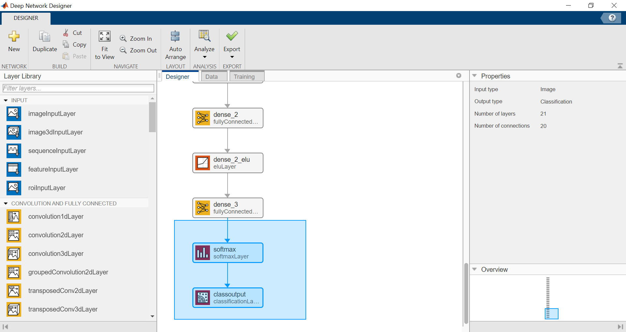

*(programmatic alternative)*Remove layers used for regression and add the layers for a classification with 5 classes

netGraph = layerGraph(layers);

clf; plot(netGraph)



classificationLayers = [fullyConnectedLayer(5,"Name","dense_3"), ...

softmaxLayer("Name","softmax"), ...

classificationLayer("Name","classoutput")];

netGraph = removeLayers(netGraph, {'dense_3', 'RegressionLayer_dense_3'});

netGraph = addLayers(netGraph,classificationLayers);

layers_1 = netGraph.Layers

layers_1 =

21×1 Layer array with layers:

1 'conv2d_5_input' Image Input 66×200×3 images

2 'conv2d_5' Convolution 24 5×5 convolutions with stride [2 2] and padding [0 0 0 0]

3 'conv2d_5_elu' ELU ELU with Alpha 1

4 'conv2d_6' Convolution 36 5×5 convolutions with stride [2 2] and padding [0 0 0 0]

5 'conv2d_6_elu' ELU ELU with Alpha 1

6 'conv2d_7' Convolution 48 5×5 convolutions with stride [2 2] and padding [0 0 0 0]

7 'conv2d_7_elu' ELU ELU with Alpha 1

8 'conv2d_8' Convolution 64 3×3 convolutions with stride [1 1] and padding [0 0 0 0]

9 'conv2d_8_elu' ELU ELU with Alpha 1

10 'conv2d_9' Convolution 64 3×3 convolutions with stride [1 1] and padding [0 0 0 0]

11 'conv2d_9_elu' ELU ELU with Alpha 1

12 'flatten' Keras Flatten Flatten activations into 1-D assuming C-style (row-major) order

13 'dense' Fully Connected 100 fully connected layer

14 'dense_elu' ELU ELU with Alpha 1

15 'dense_1' Fully Connected 50 fully connected layer

16 'dense_1_elu' ELU ELU with Alpha 1

17 'dense_2' Fully Connected 10 fully connected layer

18 'dense_2_elu' ELU ELU with Alpha 1

19 'dense_3' Fully Connected 5 fully connected layer

20 'softmax' Softmax softmax

21 'classoutput' Classification Output crossentropyex

**Train the model:** (I am using my CPU here, but I recommend to speed it up on a GPU)

initialLearnRate = 0.001;

maxEpochs = 30;

miniBatchSize = 100;

options = trainingOptions("adam", ...

"MaxEpochs",maxEpochs, ...

"InitialLearnRate",initialLearnRate, ...

"Plots","training-progress", ...

"ValidationData",valData, ...

"ValidationFrequency",10, ...

"LearnRateSchedule","piecewise", ...

"LearnRateDropPeriod",10, ...

"LearnRateDropFactor",0.5, ...

"ExecutionEnvironment","parallel",...

"Shuffle","every-epoch");

net = trainNetwork(trainData, layers_1, options);

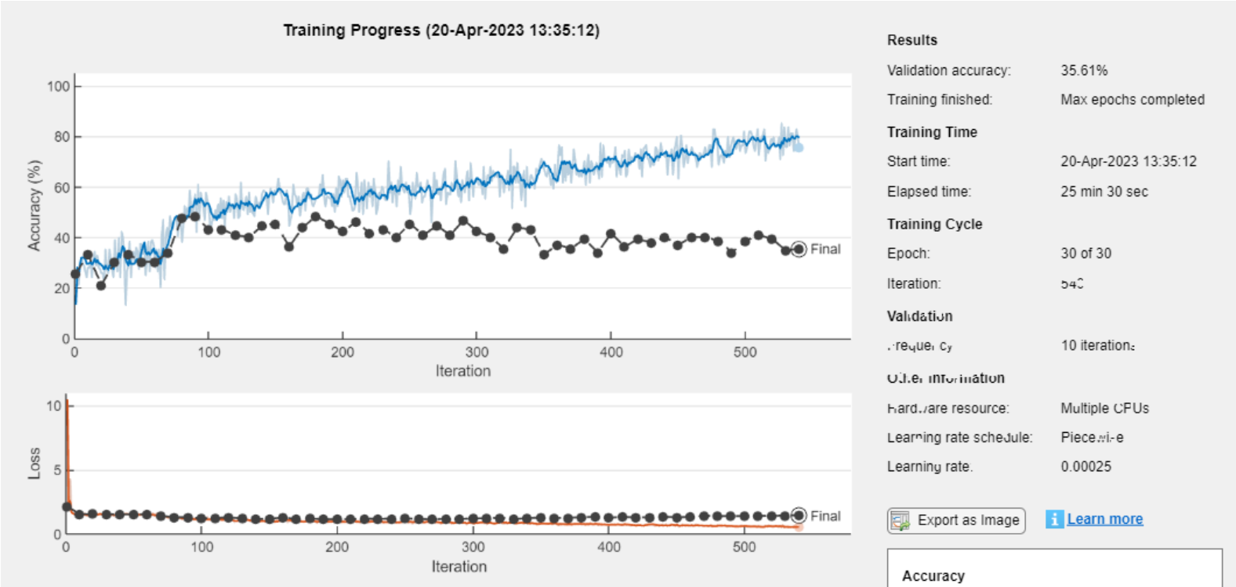

**Save the model:** Save the new trained network in a MAT format.

model_name = "net-class-30-1e-4-drop10-0_5";

% classification-epochs-learning_rate-drop_period-drop_factor

save("model_name+".mat","net")

Export it to a ONNX Network format.

exportONNXNetwork(net,model_name+".onnx")

**Test the model:**

Plot predicted and ground truth values for steering angle using the testing dataset.

model_name = "net-class-30-1e-4-drop10-0_7"; % classification-epochs-learning_rate-drop_period-drop_factor

load("models/"+model_name+".mat","net")

predSteering = classify(net, testData);

figure

startTest = 1;

endTest = 20;

plot(predSteering(startTest:endTest), 'r*', "MarkerSize",10)

hold on

plot(imdsTest.Labels(startTest:endTest), 'b*')

legend("Predictions", "Actual")

hold off



Display the confusion matrix.

confMat = confusionmat(imdsTest.Labels, predSteering);

confusionchart(confMat)



Display the testing image and the predicted label along with the ground truth.

numberImages = length(imdsTest.Labels);

i = 42;

img = readimage(imdsTest, i);

imshow(img),title(char(imdsTest.Labels(i)) + "/" +char(predSteering(i)));

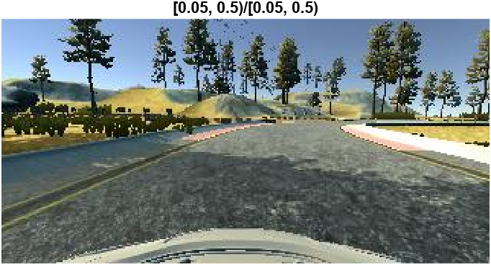

To test your model directly with the driving simulator, you can switch the simulator to “autonomous mode” and run the script drive.py.

1. Python ranking #1 in the TIOBE index in 2021: <https://www.tiobe.com/tiobe-index/>
2. EISPACK – computes the eigenvalues and eigenvectors of matrices: <https://en.wikipedia.org/wiki/EISPACK>
3. LINPACK – Linear algebra package in Fortran: <https://en.wikipedia.org/wiki/LINPACK>
4. Foreword for “Programming Python” Guido van Rossum (1996): <https://www.python.org/doc/essays/foreword/>
5. Scilab: <https://scilab.org/>
6. Interview with Claude Gomez, former CEO of Scilab Enterprises: <https://www.d-booker.fr/content/81-interview-with-claude-gomez-ceo-of-scilab-enterprises-about-scilab-and-its-development>
7. Register to OpenWeatherMap.org: <https://home.openweathermap.org/users/sign_up>
8. OpenWeatherMap current weather API: <https://openweathermap.org/current>
9. Change default environment of Python interpreter <https://www.mathworks.com/help/matlab/ref/pyenv.html>
10. Python Dictionary: <https://docs.python.org/3/tutorial/datastructures.html#dictionaries>
11. MATLAB Structure: <https://www.mathworks.com/help/matlab/ref/struct.html>
12. Double-precision arrays: <https://www.mathworks.com/help/matlab/ref/double.html>
13. Characters and Strings: <https://www.mathworks.com/help/matlab/characters-and-strings.html>
14. Dates and Time: <https://www.mathworks.com/help/matlab/date-and-time-operations.html>
15. Python List: <https://docs.python.org/3/tutorial/datastructures.html#more-on-lists>
16. MATLAB Compiler SDK: <https://www.mathworks.com/help/compiler_sdk/>
17. MATLAB Production Server: <https://www.mathworks.com/help/mps/>
18. Create client programs using the RESTful API:   
    <https://www.mathworks.com/help/mps/restful-api-and-json.html>
19. Create a MATLAB Production Server Python Client:

    <https://www.mathworks.com/help/mps/python/create-a-matlab-production-server-python-client.html>
20. Versions of Python Compatible with MATLAB Products by Release: <https://www.mathworks.com/support/requirements/python-compatibility.html>
21. Windows installer (64-bit): <https://www.python.org/ftp/python/3.10.10/python-3.10.10-amd64.exe>
22. Anaconda’s terms of services: <https://www.anaconda.com/terms-of-service>
23. open-source Anaconda Distribution: <https://www.anaconda.com/products/distribution>
24. Anaconda Professional license: <https://www.anaconda.com/products/professional>
25. WinPython: <https://winpython.github.io/>
26. Conda-forge: <https://conda-forge.org/>
27. Miniconda installer from Conda-forge: <https://github.com/conda-forge/miniforge>
28. Micromamba doc: <https://mamba.readthedocs.io/> - on Linux : curl micro.mamba.pm/install.sh | bash
29. PATH: <https://en.wikipedia.org/wiki/PATH_(variable)>
30. Python Package Index (PyPI) <https://pypi.org/>
31. Pandas <https://pandas.pydata.org>
32. Python virtual environment: <https://docs.python.org/3/tutorial/venv.html>
33. Launch of Project Jupyter at SciPy 2014: <https://speakerdeck.com/fperez/project-jupyter>
34. ipython-0.0.1 - <https://gist.github.com/fperez/1579699>
35. SageMath mathematics software system licensed under the GPL: <https://www.sagemath.org/>
36. ZeroMQ Protocol: <https://zeromq.org/>
37. MATLAB Kernel for Jupyter developed by the community: <https://github.com/Calysto/matlab_kernel>
38. Eclipse IDE, famous for JAVA development: <https://en.wikipedia.org/wiki/Eclipse_(software)>
39. Language Server Protocol: <https://microsoft.github.io/language-server-protocol/overviews/lsp/overview/>
40. Pyodide: <https://pyodide.org/en/stable/index.html>
41. Out-of-Process Execution of Python Functionality: <https://www.mathworks.com/help/matlab/matlab_external/out-of-process-execution-of-python-functionality.html>
42. Add a script to the Python path: <https://github.com/hgorr/matlab-with-python/blob/master/setUpPyPath.m>
43. Terminate process associated with Python interpreter: <https://www.mathworks.com/help/matlab/ref/pythonenvironment.terminate.html>
44. MATLAB Engine for Python on PyPI: <https://pypi.org/project/matlabengine/>
45. Install MATLAB Engine for Python: <https://www.mathworks.com/help/matlab/matlab_external/install-the-matlab-engine-for-python.html>
46. Python math module: <https://docs.python.org/3/library/math.html>
47. Forecasting the price of cryptocurrencies with Python and MATLAB <https://www.mathworks.com/videos/integrating-python-with-matlab-1605793241650.html>
48. urllib package from the Python standard library: <https://docs.python.org/3/library/urllib.html>
49. Call User-Defined Python Module:   
    <https://www.mathworks.com/help/matlab/matlab_external/call-user-defined-custom-module.html>
50. Coinbase Pro: <https://pro.coinbase.com/>
51. Add Interactive Controls to a Live Script:  
    <https://www.mathworks.com/help/matlab/matlab_prog/add-interactive-controls-to-a-live-script.html>
52. MATLAB datetime: <https://www.mathworks.com/help/matlab/ref/datetime.html#d123e298898>
53. Reload Modified User-Defined Python Module: <https://www.mathworks.com/help/matlab/matlab_external/call-user-defined-custom-module.html#buuz303>
54. Reload Out-of-Process Python Interpreter:

    <https://www.mathworks.com/help/matlab/matlab_external/reload-python-interpreter.html>
55. Rob Purser (2022). Climate Data Store Toolbox for MATLAB <https://github.com/mathworks/climatedatastore>
56. MATLAB File Exchange: <https://www.mathworks.com/matlabcentral/fileexchange/>
57. CDS Python API: <https://github.com/ecmwf/cdsapi>
58. Read data from variable in NetCDF data source <https://www.mathworks.com/help/matlab/ref/ncread.html>
59. MATLAB timetable: <https://www.mathworks.com/help/matlab/timetables.html>
60. <https://github.com/mathworks/climatedatastore/blob/main/doc/readSatelliteSeaIceThickness.m>
61. Geographic density plot: <https://www.mathworks.com/help/matlab/ref/geodensityplot.html>
62. Create and share toolboxes:   
    <https://www.mathworks.com/help/matlab/matlab_prog/create-and-share-custom-matlab-toolboxes.html>
63. How can I debug Python code using MATLAB's Python Interface and Visual Studio Code: <https://www.mathworks.com/matlabcentral/answers/1645680-how-can-i-debug-python-code-using-matlab-s-python-interface-and-visual-studio-code>
64. Configure and run the debugger:   
    <https://code.visualstudio.com/docs/python/python-tutorial#_configure-and-run-the-debugger>
65. Calling Python from Matlab - how to debug Python code? <https://stackoverflow.com/questions/61708900/calling-python-from-matlab-how-to-debug-python-code>
66. Python for MATLAB Development, Albert Danial: <https://link.springer.com/book/10.1007/978-1-4842-7223-7>
67. mat2py: <https://github.com/Apress/python-for-matlab-development/blob/main/code/matlab_py/mat2py.m>
68. py2mat: <https://github.com/Apress/python-for-matlab-development/blob/main/code/matlab_py/py2mat.m>
69. Converting data: <https://www.mathworks.com/help/matlab/matlab_external/passing-data-to-python.html>
70. MATLAB Cell Arrays: <https://www.mathworks.com/help/matlab/cell-arrays.html>
71. MATLAB cellfun Function: <https://www.mathworks.com/help/matlab/ref/cellfun.html>
72. Python Array: <https://docs.python.org/3/library/array.html>
73. Parquet file support in MATLAB: <https://www.mathworks.com/help/matlab/parquet-files.html>
74. Apache Parquet project: <https://parquet.apache.org/>
75. AI Workflow: <https://www.mathworks.com/discovery/artificial-intelligence.html>
76. Iris dataset: <https://en.wikipedia.org/wiki/Iris_flower_data_set>
77. Sample Data Sets in MATLAB: <https://www.mathworks.com/help/stats/sample-data-sets.html>
78. Iris dataset in Scikit-learn: <https://scikit-learn.org/stable/auto_examples/datasets/plot_iris_dataset.html>
79. <https://www.mathworks.com/help/matlab/matlab_external/passing-data-to-python.html#mw_b64f3777-2204-45e9-8ced-f3f363096a49> - Pass Matrices and Multidimensional Arrays to Python
80. pyrun: <https://www.mathworks.com/help/matlab/ref/pyrun.html>
81. Basic classification – Classify images of clothing: <https://www.tensorflow.org/tutorials/keras/classification>
82. Fashion MNIST: <https://github.com/zalandoresearch/fashion-mnist>
83. Python tuples in MATLAB: [www.mathworks.com/help/matlab/matlab_external/pythontuplevariables.html](http://www.mathworks.com/help/matlab/matlab_external/pythontuplevariables.html)
84. [blogs.mathworks.com/deep-learning/2022/03/18/importing-models-from-tensorflow-pytorch-and-onnx/](https://blogs.mathworks.com/deep-learning/2022/03/18/importing-models-from-tensorflow-pytorch-and-onnx/)
85. Open-source driving simulator: <https://github.com/udacity/self-driving-car-sim>
86. End-to-end learning for self-driving cars: <https://arxiv.org/pdf/1604.07316.pdf>
87. <https://www.mathworks.com/help/deeplearning/gs/get-started-with-deep-network-designer.html>
88. [www.tensorflow.org/tutorials/keras/save_and_load#save_the_entire_model](http://www.tensorflow.org/tutorials/keras/save_and_load#save_the_entire_model)